Population dependent plasticity in temperature tolerances in the social spider *Stegodyphus dumicola*: a multi-omics perspective.

Working title: Assay study

Anne Aagaard 1, Shenglin Liu 1, Tobias Sandfeld 2, Virginia Settepani 1, Marie Braad Lund 2, Kirsten Malmos 3,4, Kasper Falck-Rasmussen 1, Jesper Bechsgaard 1, Koen Verhoeven 5, Thomas Vosegaard 3,6, Andreas Schramm 2 and Trine Bilde 1,*

Iulia Darolti 7, Judith Mank 7, Tom Tregenza 8, Jesper Givskov Sørensen 1

1 Section for Genetics, Ecology & Evolution, Department of Biology, Aarhus University, Aarhus C, Denmark

2 Section for Microbiology, Department of Biology, Aarhus University, Aarhus C, Denmark

3 Interdisciplinary Nanoscience Center (iNANO); Aarhus University, Aarhus C, Denmark.

4 Present address: Arla Foods a.m.b.a, Agro Food Park, Aarhus N, Denmark

5 Terrestrial Ecology Department, Netherlands Institute of Ecology (NIOO-KNAW), 6708 PB Wageningen, The Netherlands

6Department of Chemistry, Aarhus University, Aarhus C, Denmark.

7 Vancouver

8 Centre for Ecology & Conservation, School of Biosciences, University of Exeter, Penryn Campus, UK

* Corresponding author: Trine Bilde, [trine.bilde@bio.au.dk](mailto:trine.bilde@bio.au.dk)

# Abstract

# Introduction

# Materials and methods

## Sample collection and natural temperature conditions

Spiders were collected from four different locations in Namibia; Betta, Karasburg, Otavi and Stampriet in April 2017 (see Fig. 1A). From each location up to 20 nests were sampled, and brought to the laboratory at Aarhus University. Temperature data from the four collection sites were extracted from Aagaard et al (2022) (Fig. 1B).

## Population phylogenetic reconstruction

To construct the phylogenetic relationship among the studied populations we downloaded mapped sequence data from Aagaard et al (2021), and bcftools were used to construct vcf-files (‘mpileup’ without indel calling (-I) and ‘call’, (Li, 2011)). Samtools faidx (Li et al., 2009) was used to extract coding positions, bcftools ‘consensus’ (Danecek & McCarthy, 2017) to call consensus sequences, that were subsequently joined to one sequence per location and aligned. Every 50th exon was extracted, and a neighbor-joining tree was built by Mega X (Kumar, Stecher, Li, Knyaz, & Tamura, 2018). The alignment was approximately 1,500,000 bp, and 1000 bootstraps were run to support branching.

## Common gardens setup

All nests were kept at room temperature (about 21˚C) for at least two weeks before acclimation treatment. The spiders were acclimated to five constant thermal regimes: 15, 19, 23, 25 and 29°C prior to testing their thermal tolerances. All regimes had a 12h/12h light/dark photoperiod. From each nests, 150 individuals were divided among five plastic boxes (10x10x15 cm) with two sides cut out and covered with mesh to allow airflow, and distributed among the five thermal acclimation regimes. Due to practicalities regarding thermal tolerance testing and initial size differences among spiders, two nests were split and put in the five acclimation treatments each weekday for 8 weeks. The order of nests were decided by always taking the two nests with the largest spiders evaluated by eye. After 42 days of thermal acclimation, the spiders’ thermal tolerances were tested.

During the acclimation period the spiders were sprayed with water thrice per week and fed twice per week. Feeding items were houseflies, crickets, mealworms, grasshoppers, and cockroaches.

## Growth and survival

To assess spider survival and growth at lab conditions, spiders alive were counted and weighted three times during the course of the acclimation period. Growth factor was measured as mass relative to the initial mass measurement. Survival data was collected as the number of live spiders in the nest at the three time points, and only the first and last time point was used to assess survival. We used lm (base R) to model growth and glm (base R) with binomial family and logit link to model survival data. Best models were found using the step function in R, based on AIC values.

## Thermal tolerance

After thermal acclimation, we tested thermal tolerances by estimating critical thermal maximum (CTmax) and chill-coma recovery (CCR) as measures of heat and cold tolerances, respectively. Twenty individuals from each box were weighed separately before they were put into 5 ml glass vials, watertight lids were added, and they were divided randomly between the two tests. The vials were attached to a rack, and the rack was submerged into a water-filled aquarium.

### CTmax:

The water temperature were regulated to 25 °C prior to the experiment, and immediately heated with a rate of 0.1 °C per minute after submerging the racks, while stirring the water with a pump to ensure as similar water temperature as possible surrounding all vials. Four cameras were used to each record 25 spiders until the water had reached 55 °C. The footage was subsequently manually inspected to identify the time that each individual spider did not move anymore, and this time was converted to temperature and used as the CTmax estimate (Figure S1).

### CCR:

Ethylene glycol were added to the aquarium before the CCR experiment to avoid the water freezing. The temperature of the water ethylene glycol mixture were regulated to 0 °C prior to the experiment. The rack was submerged and the temperature kept at 0 °C for 150 minutes, before increasing the temperature with 0.5 °C per min. Keeping the spiders at 0 °C for 150 minutes causes the spiders to enter chill coma, a reversible physiological state preventing movement (Findsen, Pedersen, Petersen, Nielsen, & Overgaard, 2014). Four cameras were used to each record 25 spiders until the water had reached 25 °C. The footage was subsequently manually inspected to identify the time that each individual spider moved, and this time was converted to temperature and used as the CCR estimate (Figure S1).

We argue that CTmax and CCR measures are ecologically relevant for *S. dumicola* spiders. Temperature often get extremely high during the day (more than 50 degrees within the nests (REF)) and subzero during the night in their natural habitats. Spiders are therefore likely to both be exposed to temperatures that challenge their heat tolerance and to enter chill coma. We therefore believe these measures directly relate to fitness.

### Thermal tolerance analyses

All analyses were performed using R v4.0.3 (R Core Team, 2020). Critical thermal maximum (CTmax) and CCR were analyzed with ANOVA on a linear model using population and acclimation temperature as fixed factors. We calculated means of CTmax and CCR for each nest, and these were used as data points in the statistical analyses.

## DNA methylation

### DNA extraction and bisulfite sequencing:

One spider from each of the 200 boxes were put in a minus 80 °C freezer after 42 days of thermal acclimation. DNA was extracted from each spider separately using QIAGEN DNeasy Blood and Tissue kit (Qiagen, Hilden, Germany). The DNA from all individuals from same population and acclimation temperature was pooled in equal concentrations before bisulfite conversion and sequenced; twenty pools in total (4 populations x 5 acclimation temperatures). 150 bp paired end sequencing was performed on an Illumina HiSeq2500 platform. λDNA was used as a control for a bisulfite conversion rate, and 99% of the unmethylated cytosines were converted. Library construction and sequencing were performed by Novogene (Hongkong).

### DNA methylation analyses:

We used FastQC v.0.11.5 (‘FastQC’, 2016) and Trim Galore v.0.4.1 (‘Trim Galore’, 2015) to check and trim bisulphite reads, before mapping them to the *S. dumicola* reference genome, using Bismark v.0.19.0 (Krueger & Andrews, 2011). Bismark was also used to extract methylation cites. Exact details on trims etc. can be found in (Liu, Aagaard, Bechsgaard, & Bilde, 2019). We filtered for coverage of c cites between 10 and 32, and further analysis focused only on CpG sites. To get a methylation measure covering gene bodies, we calculated weighted methylation level within each gene (Schultz, Schmitz, & Ecker, 2012). To test whether genes were differentially methylated with respect to the main effects (Population and Acclimation temperature), we ran the methylation counts of genes through DSS v.2.34.0 (Park & Wu, 2016), that employs a beta-binomial regression model with arcsine link. In DSS we tested the main effects using the DML.test function (uses wald test), keeping genes with fdr<0.1.

## Gene expression

### RNA extraction and sequencing:

Extraction of RNA was done on one spider from each of ten nests from every population/treatment group (200 in total), after 42 days of thermal acclimation. Spiders were flash frozen in liquid nitrogen in preparation for RNA extraction. Extraction was done using QIAGEN RNeasy Mini Kit (Qiagen, Hilden, Germany). 199/200 extractions succeeded and subsequent libraries were sequenced with 150bp paired end on Illumina HiSeq2500. Further extraction and sequencing details are described in (Liu et al., 2019).

### Gene expression analyses:

RNA sequencing reads were analysed following a protocol from (Pertea, Kim, Pertea, Leek, & Salzberg, 2016), with specific parameters earlier described in (Liu et al., 2019). In short, we used FastQC v. 0.11.5 (‘FastQC’, 2016) and trimmomatic v. 0.39 (Bolger, Lohse, & Usadel, 2014) for quality check and trimming, HISAT2 v. 2.1.0 (Kim, Langmead, & Salzberg, 2015) for mapping and stringtie v. 2.1.1 (Pertea et al., 2015) for transcriptome assembly and quantification. Deterring from the protocol, we used DEseq2 v. 1.26 (Love, Huber, & Anders, 2014) for differential expression analysis, estimating main effects and interactions using likelihood ratio tests (fdr<0.1) in the DEseq function. Our analyses are based only on whole genes (discarding gene parts) from the resulting count table.

## Metabolites

### Aqueous Extractions of Metabolites for NMR analysis:

Dry spider samples (XX mg, how were they obtained) were dissolved in 700 µL D2O, 20 mM sodium phosphate buffer containing 0.08 mM sodium trimethylsilylpropanesulfonate (DSS). The phosphate buffer was mixed by Na2HPO4 and NaH2PO4 to obtain pH = 7.8. The dissolved sample was centrifuged for 10 min at 4248 x g, and the supernatant was transferred to 5 mm samplejet NMR tubes using glass pasteur pipettes.

### Hydrophobic Extractions of Metabolites for NMR analysis:

Dry spider samples (100 mg) were placed in matrix tubes, and 2 mL cold (Temp) 80% MeOH was added. Samples were vortexed for XX min. The dry material was extracted twice with program 1 fast prep (4.5 m/s, 20s, custom), then centrifuged for 5 min (13000 rpm, 4 °C how many g?). The supernatant was transferred to weighted freeze-dry tubes and freeze dried. 4 mL cold (temp) MQ water was added to the residual pellet, which was then extracted twice with program 1 fast prep (4.5 m/s, 20s, custom). The sample was centrifuged for 5 min, 13000 rpm, 4 °C. The supernatant was added to the MeOH fraction in freeze-dry tubes and flash freezeed and freeze-dried. Residual spider and matrix was transfered to glass beakers using 1 mL MeOH add 5 mL CHCl3, then incubated in vials at room temperature for 5 min. How are the NMR samples made from this?

## NMR experiments

1H NMR 1D experiments were recorded on a Bruker 500-MHz spectrometer equipped with a Bruker Avance-II console, a 5 mm triple resonance probe, and an automatic sample changer (SampleJet, Bruker). For all samples automatic tuning, locking and shimming were applied, and experiments were performed at 295.0 K. Experiments for the aqueous samples were recorded using the standard CPMG pulse sequence named cpmgpr1d with 64 scans and an acquisition time of 3.46 s (spectral width 20 ppm) followed by a repetition delay of 4 s, while experiments for the hydrophobic extracts were recorded using standard single-pulse excitation with the Bruker pulse program zg with 64 scans and an acquisition time of 8 s (spectral width 16 ppm) followed by a repetition delay of 2 s. The spectral width was 20 ppm. Spectra were processed using MestReNova (v. 14.2, Mestrelab research, ES). All spectra were referenced using the solvent signal at 7.26 ppm, and processed using 1.5 Hz exponential apodization followed by global whitening phase and ablative baseline correction.

### LC-MS

#### Extraction for LC-MS

Samples of adult *S. dumicola* females, grouped after nest and population, were sequentially extracted with cold methanol (80%) and afterward cold HPLC-grade water in TeenPrep™ Lysing Matrix E (15 mL tubes) using a FastPrep-24™ 5G Homogenizer (MP Biomedicals, USA). The resulting extraction fractions were mixed and diluted to 8% methanol with HPLC-grade water to enable flash freezing in liquid nitrogen and lyophilization. The frozen extracts were lyophilized on MicroModulyo Freeze Dryer (ThermoFisher Scientific, USA) coupled to a Chemistry-HYBRID RC 6 vacuum pump (Vacuubrand GmbH, Germany) till dry and stored at -80°C until further processing. Metabolite profiles of extracts were obtained with GC-MS and UHPLC-MS as described below. All analysis was conducted on all 10 samples in technical triplicates.

**Gas Chromatography coupled to Mass Spectrometry (GC-MS) analysis**

GC-MS analysis was done on an Agilent 7890B gas chromatograph (Agilent, USA) coupled to a mass selective detector (Agilent 5977B Inert Plus Turbo MSD). Prior to injection, ̴ 1 mg extract was derivatized with 40 μl MeOX (Methoxyaminhydrochlorid) at 37°C for 90 min and 80 μl MSTFA (N-Methyl-N-trimethylsilyltrifluoracetamid) at 37°C for 30 min in accordance with Liebeke et al. 2008. Samples were injected with an Agilent SSL-injector (Split 25:1 at 230°C, 2.0 μL; carrier gas: Helium 1,0 mL/min (60 kPa) at 110°C; pressure rise: 6 kPa/min). Chromatography was performed using a 30-m HP-5ms column (J&W Scientific, USA) with 0.25 mm i.d. and 0.25 μm film thickness. The oven program started with 1 min at 70°C, the oven temperature was increased at 1,5°C/min to 76°C; 5°C/min to 220°C; 20°C/min to 325°C with an 8 min hold. The MS was operated in electron impact mode with an ionization energy of 70 eV. Full scan mass spectra were acquired from 50-500 m/z at a rate of 2.74 scans/s and with a 6.00-min solvent delay. The detected compounds were identified by processing the raw GC-MS data with MassHunter version B 8.00 software (Agilent, USA) and comparing retention times and mass spectra of detected metabolites with those of standard compounds, which were measured for an in-house database. Unknown peaks were analyzed with Fiehn library (Kind et al. 2009) and NIST 2017 mass spectral database 2.0 d (National Institute of Standards and Technology, USA) and were listed with the database score.

**Ultra-High-Performance Liquid Chromatography coupled to Quadrupole Time-of-Flight Mass Spectroscopy (UHPLC-MS) analysis**

UHPLC−MS analysis was obtained with Acquity UPLC I-Class system (Waters Corporation, USA) coupled to a Q-TOF maXis Impact mass spectrometer (Bruker Daltonics GmbH, Germany) operated in positive (ESI+) or negative (ESI-) ionization mode. Before injection, extracts (1mg/mL) were resuspended in 0.1% formic acid in water and quality control (QC) samples were prepared by pooling equal volumes of each sample. Samples were injected with an autosampler, 2 μL was injected in ESI+ mode and 10 μL in ESI- mode, and the sample temperature was 6°C. Liquid chromatographic (LC) separation was performed on an Acquity UPLC HSS T3 Column (2.1 mm X 100 mm, 1.8 μm) (Waters Corporation). The column temperature was 50 °C. Mobile phase A consisted of 0.1% formic acid in Milli-Q water, and mobile phase B consisted of 0.1% formic acid in 50:50 acetonitrile/methanol (LCMS Hypergrade, Sigma-Aldrich). The mobile phase started at 100% A for 2 min, linear increase from 0% to 40% B at 2 to 6 min, from 40% to 60% B at 6 to 6.5 min, from 60% to 88% B at 6.5 to 11 min, from 88 to 100% B at 11 to 11.5 min, 100% B at 11.5 to 17 min. This was followed by a linear decrease from 100% to 0% B at 17 to 18.1 min and afterward 100% A for column equilibration at 18.1 to 21.0 min. The MS was operated with a mass range of m/z 50−1000, a sampling rate of 4 Hz, and the capillary voltage was 4000 V (ESI+) and 2500 V (ESI-). The nebulizing gas pressure was 4 bars, drying gas flow was 11 L/min and temperature was 220 °C. Instrument calibration was done with sodium formate for both ESI+ mode and ESI- mode and repeated for the first 20 sec (30 scans) of each analysis. In addition, all samples were auto-calibrated in DataAnalysis (Bruker Daltonics, Germany), before peak identification, to improve mass accuracy further. To validate the performance of the instrument control samples, with 15 known metabolites, were analyzed at the beginning and end of each UHPLC-MS run, and a quality control (QC) sample (a pool of all samples) was injected in the beginning and following every approximately five samples.

Data were examined in DataAnalysis (Bruker Daltonics, Germany) and converted to the file mzML format by CompassXport (Bruker Daltonics, Germany). Features, described by an m/z value, a retention time, and an area under the peak curve, were extracted with XCMS (Smith et al. 2006) using R project, version 3.2.0 (http://www.R-project.org). Removal of calibration scans (30 scans) was performed prior to peak detection. CAMERA was used for grouping features and annotations of isotopes and adducts (Kuhl et al. 2012). Peak detection was performed using the CentWave algorithm (Tautenhahn et al. 2008) with 12 ppm resolution and with a signal-to-noise threshold of six. Retention time correction was performed with the Obiwarp algorithm (Prince and Marcotte 2006). For identification, an in-house database, Metlin (www. metlin.scripps.edu), The Human Metabolome Database (www.hmdb.ca), and Metfrag (www.msbi.ipb-halle.de/MetFrag) were used. The identity of the metabolites was confirmed by comparison of *m/z* values, retention time, and fragments of available authentic standards with those obtained in the samples. The level of identification was designated according to the guidelines of the Metabolomics Standard Initiative (Sumner et al. 2007).

### Metabolite data analyses

Peak-intensity tables were obtained using the online tool MetaboAnalyst v.4.0 (Xia & Wishart, 2011), but subsequent analyses were done using MetaboAnalystR v.3.2.0 (Pang, Chong, Li, & Xia, 2020) in R v.4.05 (R Core Team, 2021). Both LC-MS and NMR data was normalized to sum and pareto scaled before we tested for main effects and interaction effects using Anova with false discovery rate (fdr) of 0.05 from within MetaboAnalystR.

## Microbiome

### DNA extraction and sequencing

Three adult female spiders from each nest at 19˚C and 29˚C (total of…XX) were sampled and whole spiders were used to extract DNA for amplicon sequencing of the V3-V4 region of the 16S rRNA following the protocol in (Busck et al., 2020). The reads were subsequently run through the dada2 pipeline and taxonomic classification, after which relative abundances of the ASVs were calculated.

### Microbiome analysis

Microbial ASVs were filtered using a prevalence threshold, to retain only ASVs that are present in >25% of nests within a population. This retained 78 ASVs. Following filtration, anova (with fdr and threshold of 0.05) was used to test the main and interaction effects on each ASV.

# Results

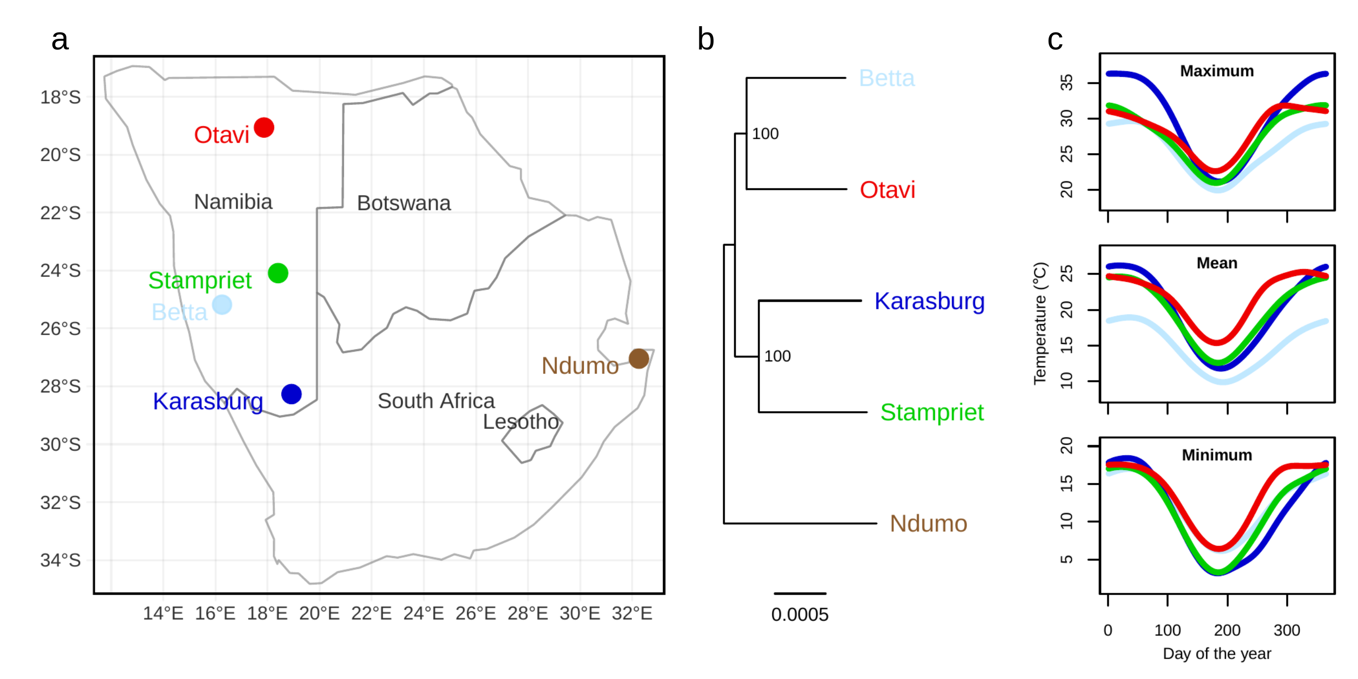

*Figure 1: Information about the sampling populations. a) Map of the populations in Namibia and the outgroup Ndumo from South Africa, b) Phylogeny of the populations and c) maximum, mean and minimum temperature over the course of a year at the sampling sites.*

## Temperature and population phylogeny

The mean daily temperature is on average highest in Otavi (21.6˚C), lowest in Betta (17.8˚C), and intermediate in Stampriet and Karasburg (19.6˚C and 19.7˚C), while the mean daily variation across the year is highest in Karasburg, and lowest in Betta (K= 18.97˚C > S=15.94˚C > O= 14.66˚C > B=13.22˚C). The phylogenetic reconstruction shows that Otavi and Betta are sister populations, as is Stampriet and Karasburg (Figure 1b). This does not completely reflect the geographical location of the populations (Figure 1a), nor is it reflecting the abovementioned mean temperatures at the geographical location (Figure 1c). The daily variation in temperature is more similar between Stampriet, Otavi and Betta (Figure S2), and therefore also do not completely reflect the phylogenetic pattern.

## Growth and survival

The best model for growth (full model, lm in r: growth ~ population*temperature, R2=0.49, F(7,296)=40.66, p<2.2e-16) shows an overall effect of temperature acclimation, no effect of population and no interaction effect (anova). Inspecting the model more closely (suppl table XGROW), reveals the effect of acclimation temperature (β=0.1, p< 2e-16) and a small interaction effect with temperature for Otavi (β=-0.029, p=0.045). Graphics with growth data can be seen in Figure S3a.

The best model for survival was the additive model (glm in R, family:binomial, logit link: Survival ~ Population + Temperature, AIC=1665, p<2e-16). The model found significant effects of both population, driven by Karasburg (β=0.42, p=5.2e-05, suppl table XSURV), and temperature acclimation (β=0.1, p<2e-16). For graphical representation of survival data see Figure S3b.

We consequently conclude that spiders from the four populations do close to equally well under laboratory conditions, suggesting that their overall physiological conditions are very similar.

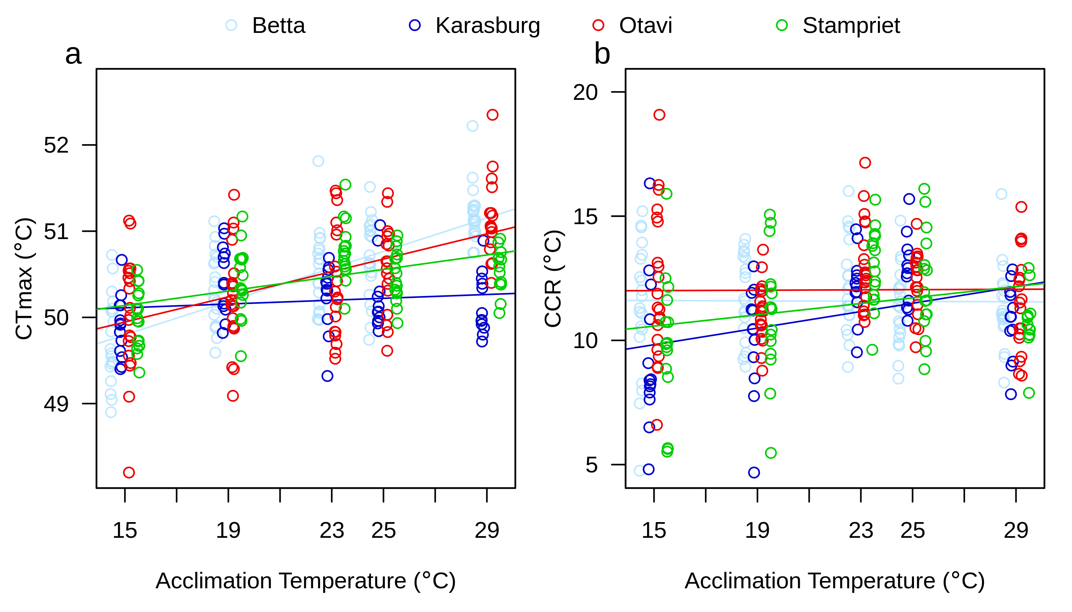

*Figure 2: Temperature tolerance tests as a function of acclimation temperature for the four populations. a) CTmax with population specific acclimation efficiencies of Betta=0.1˚C/˚C, Karasburg=0.01 ˚C/˚C, Otavi=0.07 ˚C/˚C, Stampriet=0.04 ˚C/˚C, and b) CCR with population specific acclimation capacities of Betta=-0.004 ˚C/˚C, Karasburg=0.17 ˚C/˚C, Otavi=0.004 ˚C/˚C, Stampriet=0.11 ˚C/˚C. The x-values for the points has been moved slightly for easier interpretation of the population specific responses.*

## Critical thermal maximum (CTmax)

The best model for CTmax (lm in R: CTmax ~ Population * Temperature + Mass + Feeding + Days_at_21, R2=0.41, F(10,298)=20.61, p< 2.2e-16, suppl table Xctmax) revealed an overall significant effect of both temperature acclimation (p<2.2e-16), population (p<0.000) and interaction effects on CTmax (p=1.3e-07) using anova. The model also found smaller but significant effects of mass (p=0.004), days since feeding (p=0.02) and number of days at 21˚C before undergoing treatment (p=0.02). We included mass in our analysis, since spider mass was initially different between populations, and could influence temperature tolerance measurements (Anthony, Buddle, Høye, Hein, & Sinclair, 2021; Oyen et al., 2021) and thus confound our results. Time spend in the lab could influence our results, since we – for practical reasons – could not acclimate and test all spiders at once, and thus chose the largest spiders (indicating maturity) in each population to run though treatments first. We included feeding status since feeding – for practical reasons – were done on specific days for all spiders, and feeding status could influence temperature tolerances (Manenti, Cunha, Sørensen, & Loeschcke, 2018; Nyamukondiwa & Terblanche, 2009). However, note that feeding status and days at 21˚C is not biased among populations. For visualizations of mass, feeding status and days at 21˚Csee Figure S4 and Figure S5. For CTmax, we see Betta and Otavi showing similar patterns, while Karasburg is clearly different, and Stampriet in between (Figure 2a). The populations show acclimation capacities of 0.1˚C/˚C (Betta), 0.01˚C/˚C (Karasburg), 0.07˚C/˚C (Otavi), 0.04˚C/˚C (Stampriet) for CTmax.

Investigating the difference in trends using emtrends in r, reveal that Otavi and Betta are indeed similar, but differ from Stampriet and Karasburg (B & O >< S & K). The population pattern for mass is different (Stampriet < Betta & Karasburg < Otavi, Figure S5), decoupling mass as a primary explanatory variable for population pattern in CTmax.

## Chill coma recovery (CCR)

The best model for CCR (linear model: CCR ~ Population + Temperature + Mass + Feeding + Population:Temperature, R2=0.098, F(9,320)=3.86, p<0.000, suppl table Xccr) revealed a significant effect of population (anova: p=0.011), acclimation temperature (p=0.02), feeding status (p=0.004, see Figure S6) and an interaction between population and acclimation temperature (p=0.03). The population effect is driven by Karasburg (β=-4.7, p=0.003), and to some extend Stampriet (β=-2.96, p=0.056). Karasburg also drives the interaction effect (β=0.17, p=0.01). The linear models reveal acclimation capacities of -0.004˚C/˚C (Betta), 0.17˚C/˚C (Karasburg), 0.004˚C/˚C (Otavi), 0.11˚C/˚C (Stampriet) for CCR. Despite the trends not being significantly different (emtrends in r package emmeans (Lenth, 2019)), we see similar population patterns as for CTmax: Otavi and Betta shows a more similar response for CCR as compared to the more similar response shared by Stampriet and Karasburg (Figure 2b).

## Gene expression

We found 13998 genes differently expressed according to population of origin, while 11807 genes show responses to acclimation temperature (Figure 3). 7669 genes were found to have both population and temperature specific responses, while 909 showed evidence of an interaction (Figure 3). 844 of the genes showing a population response in expression, were also found to have a population response in DNA methylation (hashed bars, Figure 3).

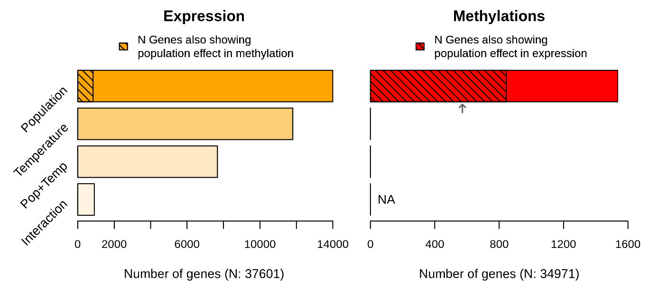

**Figure 3.** The number of genes showing population and temperature responses in gene-wise DNA methylation and gene expression data. The y axis groups consist of: genes showing population responses (Population), temperature responses (Temperature), both population and temperature responses (Pop+Temp) and an interaction between population and temperature (Interaction). The hashed lines indicate the number of genes co-occurring between genes with a population response in DNA methylation and gene expression. The arrow indicates the number of genes we expect to show a population response in both expression (DEG) and methylation (DMG) if it was random (N DEGspop / N all genes * N DMGs).

## DNA methylation

DNA methylation within genes show a population specific pattern in 1537 genes, while no genes with effect of temperature were found. We do not have power to test for interactions, indicated by NA on Figure 3.

## Correlations between DNA methylation and gene expression

Of the 1537 genes showing a population response in DNA methylation, 844 was found to also have a population specific pattern in gene expression (Hashed bars, Figure 3). However, this number is very close to the number of genes we expect to show such a pattern if there is no interaction between weighted methylation level and gene expression level (arrow, Figure 3). Correlations between weighted methylation level and level of gene expression in the common genes showing a population response, reveal a normally distributed (or slightly bimodal) histogram of correlation coefficients (expectation: left skew, Figure S7). This further indicates that higher methylation level on its own does not lead to a higher level of gene expression at least not as a general mechanism that works similar in all genes. We also test whether DNA methylation could have a stabilizing function on gene expression, by correlating genewise DNA methylation with SD of gene expression. The histogram reveal close to normally distributed correlation coefficients for weighted methylation level and SD of gene expression (expectation: right skew, Figure S8).

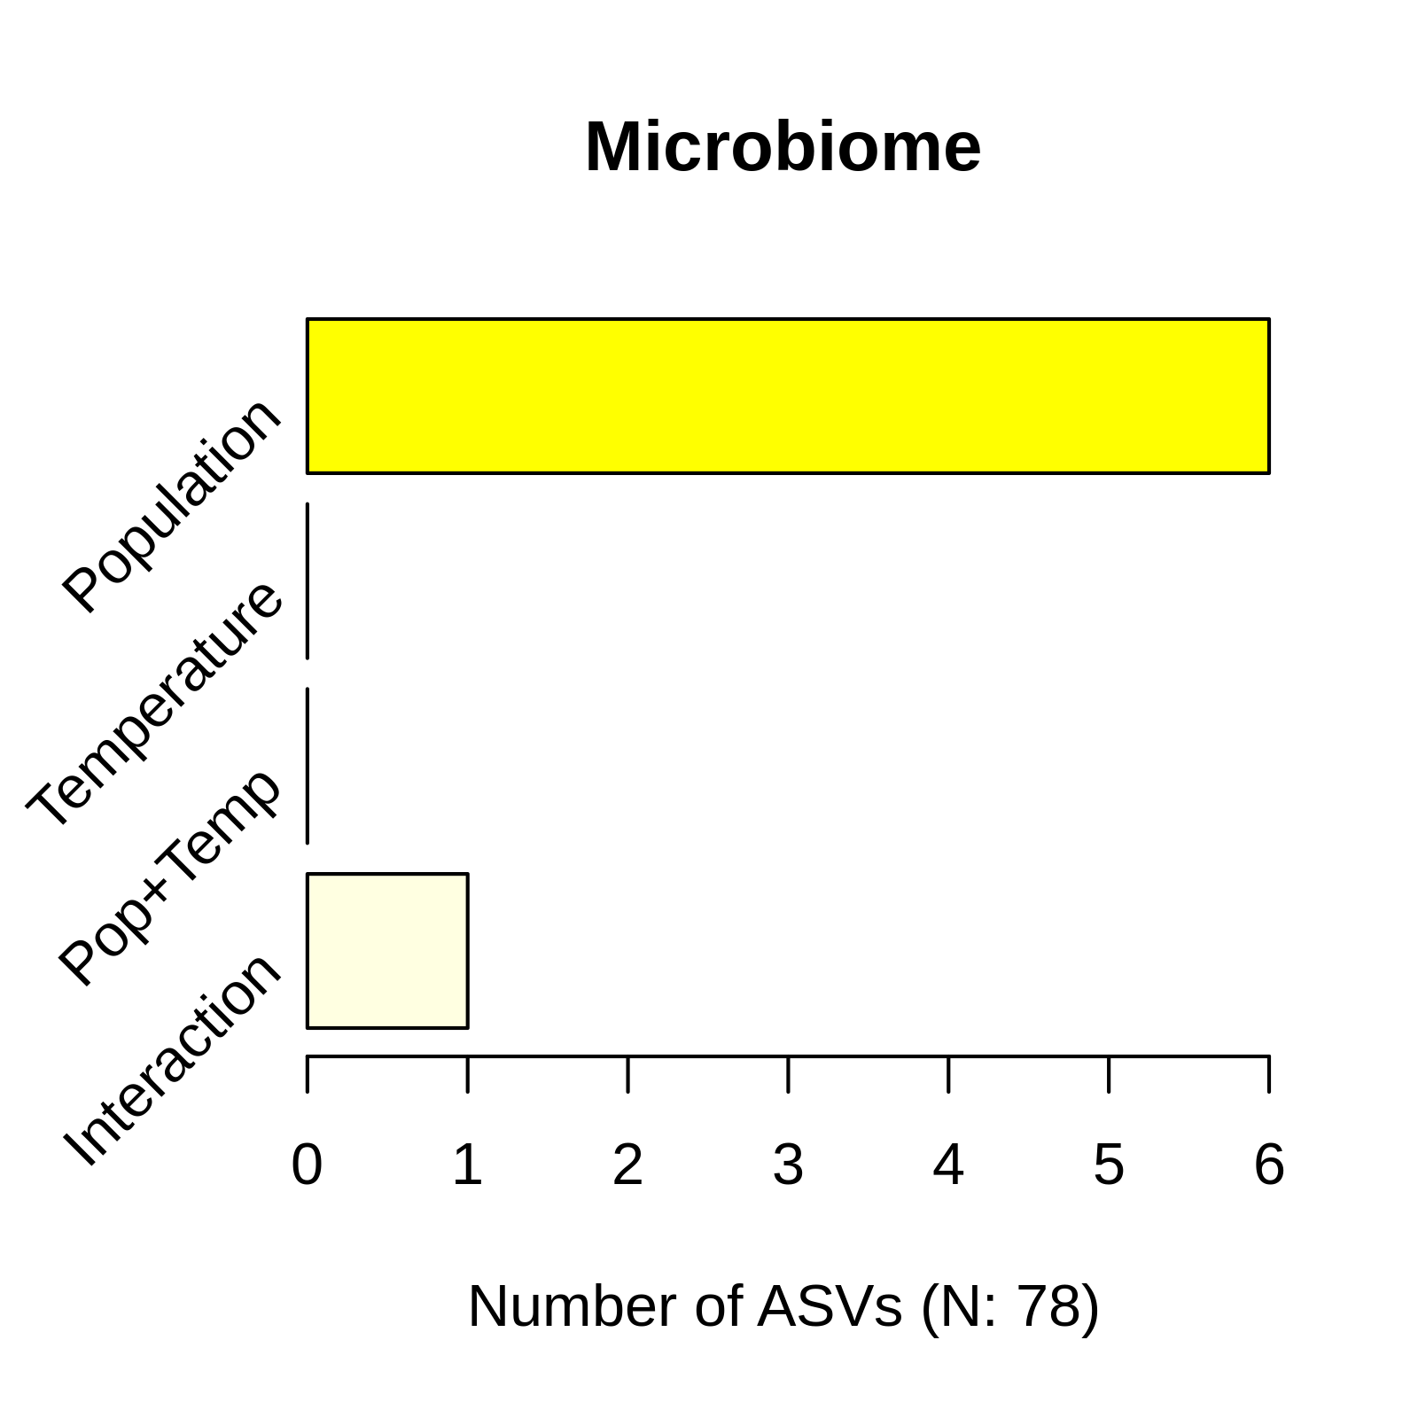

*Figure 4: Plastic and population effects on ASV level of the microbiome in S. dumicola. The total number of ASVs passing filtering criteria is 78.*

## Microbiome

78 ASVs were retained by the filtering criteria and 6 of the ASVs shows an effect of population, one of which also shows an interaction effect. The ASVs showing responses were: Mycoplasma (ASV1, 3spASV4), Borrelia (ASV12), Diploirckettsia (ASV2, 3spASV9), Weeksellaceae (ASV4), Rickettsiella (ASV6, Interaction) and Weeksellaceae (ASV7).

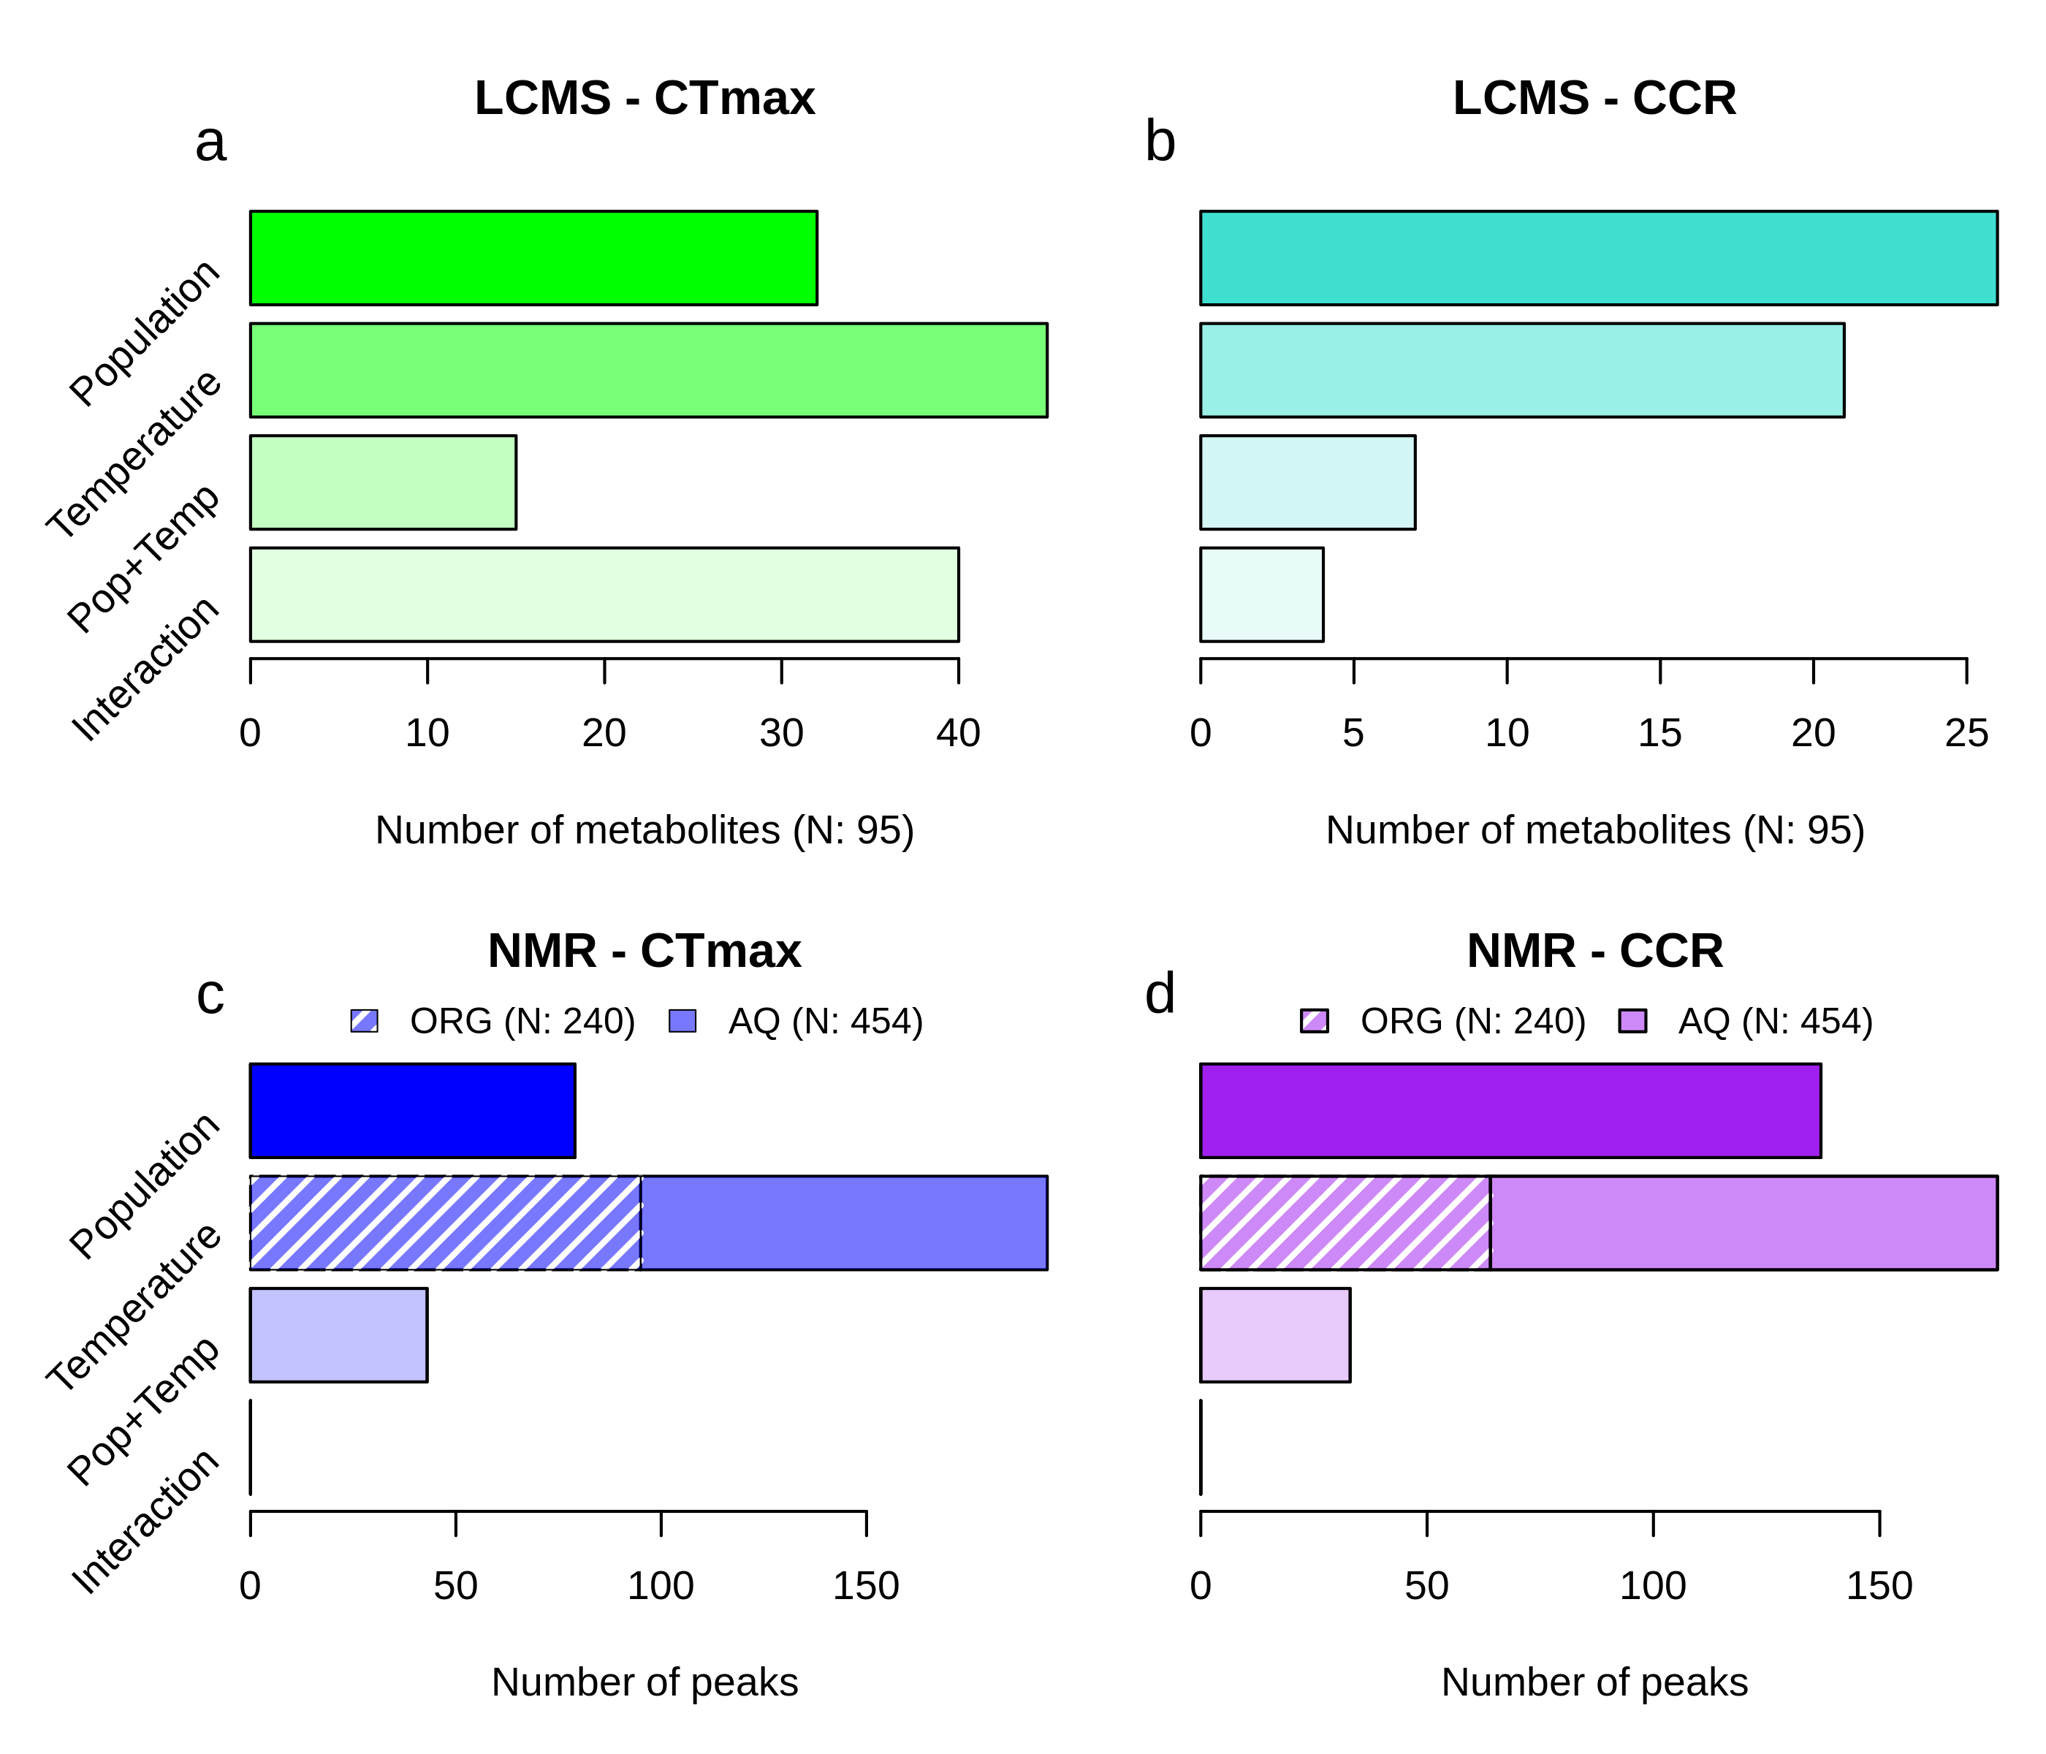

*Figure 5: Metabolome data for spiders having undergone CTmax and CCR treatment after common garden acclimation. a,b) LCMS identified metabolites of spiders having gone trhough a) CTmax treatment and b) CCR treatment. c,d) NMR peaks of spiders having gone trhough c) CTmax treatment and d) CCR treatment. The total number of metabolites or peaks identified can be seen in x axis label (a,b) or the legend (c,d).*

## Metabolome

### LC-MC (Tobias)

4188 features were retrieved using positive ionization, of which 21 could be identified in databases. Using negative ionizations, 3215 features were found, 74 of those received an identified name.

#### CTmax

We chose to focus only on named features for further analysis, a filtering retaining 75 features for spiders having gone through CTmax treatment. 60 of those features were found using negative ionization, and 15 with positive ionization.

Out of the 72 features found in CTmax spiders, 32 showed a population response, while the intensity of 45 features were found to be influenced by acclimation temperature (Figure 5a). 15 features were found to show both responses, while 40 features show interaction effects of population and acclimation temperature (Figure 5a).

#### CCR

For spiders having gone through chill coma treatment, 42 named features were found, of which 7 was found using positive ionization and 35 using negative ionization.

Of the 42 named features from CCR spiders, 26 features show a population specific response and 21 respond to acclimation temperature (Figure 5b). Features having both an effect of population and temperature reached a total of 7, while 4 features were found to have interaction effects (Figure 5b).

### NMR (Kirsten)

#### Water extractions

From the NMR spectra 454 peaks were recovered from the water extractions. The effect of population and acclimation temperature were tested on each peak individually, divided into samples having been through CTmax and CCR treatment.

##### CTmax:

454 NMR peaks were tested separately using analysis of variance, and 79 showed a population effect, 99 an acclimation temperature effect with 43 showing both population and acclimation effects, while no significant interactions were found (solid bars, Figure 5c).

##### CCR:

The 454 NMR peaks were tested separately, and 137 showed a population effect, 112 an effect of acclimation temperature and 33 showing both population and acclimation effects, while no significant interactions were found (solid bars, Figure 5d).

#### Organic extractions

From the organic extractions, 240 peaks were found in the NMR spectra. The samples were divided into CTmax and CCR treatment and tested individually for effects of population and acclimation temperature. Most noticeable is that no effect of population was found for organic extractions.

##### CTmax:

The 240 NMR peaks were tested separately, and 95 peaks showed an acclimation effect, while no peaks revealed an effect of population or interaction between population and acclimation temperature (hashed part, Figure 5c).

##### CCR:

240 NMR peaks were tested separately, and 64 peaks revealed an acclimation temperature effect, while no peaks showed a population nor an interaction response (hashed part, Figure 5d).

## Discussion

### Conclusive remarks

.

# Supplement:

**Figure S1:** time to temperature plots for CTmax and CCR. Colored circles are measurements of temperature at a given time during ramping, while black circles indicate the mean with standard deviation. A linear model has been fitted on the average: lm = 0.098x + 42.99 for CTmax, and lm = .5x + 0.254 for CCR.

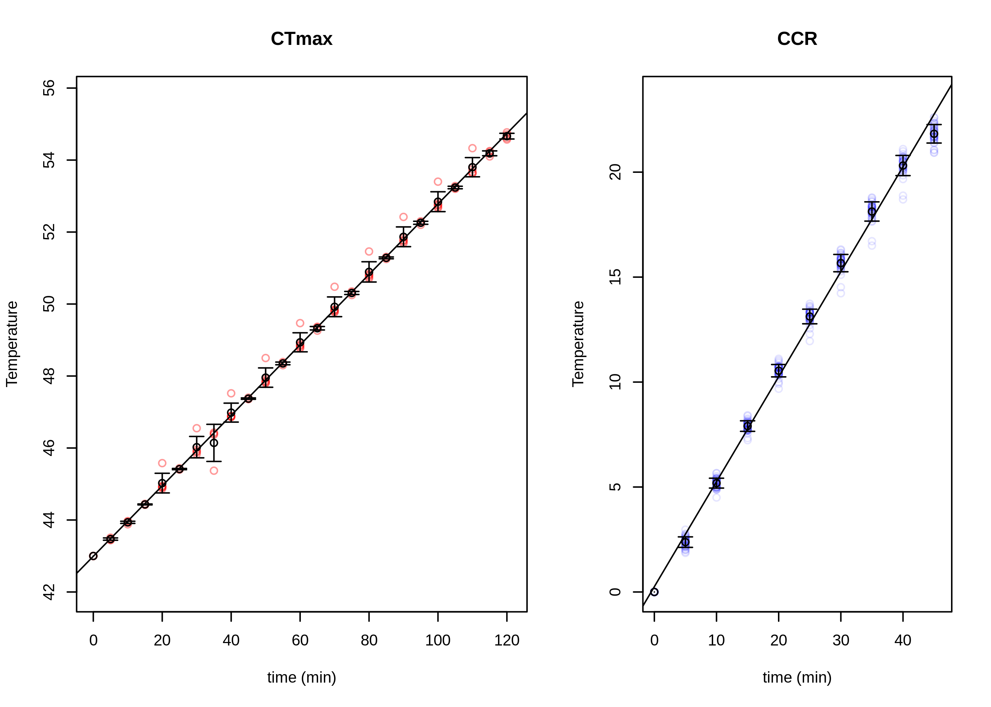

**Figure S2**: Variation in daily temperature (daily maximum – daily minimum).

**Figure S3:** Graphics of growth factor and survival data as a function of acclimation temperature.

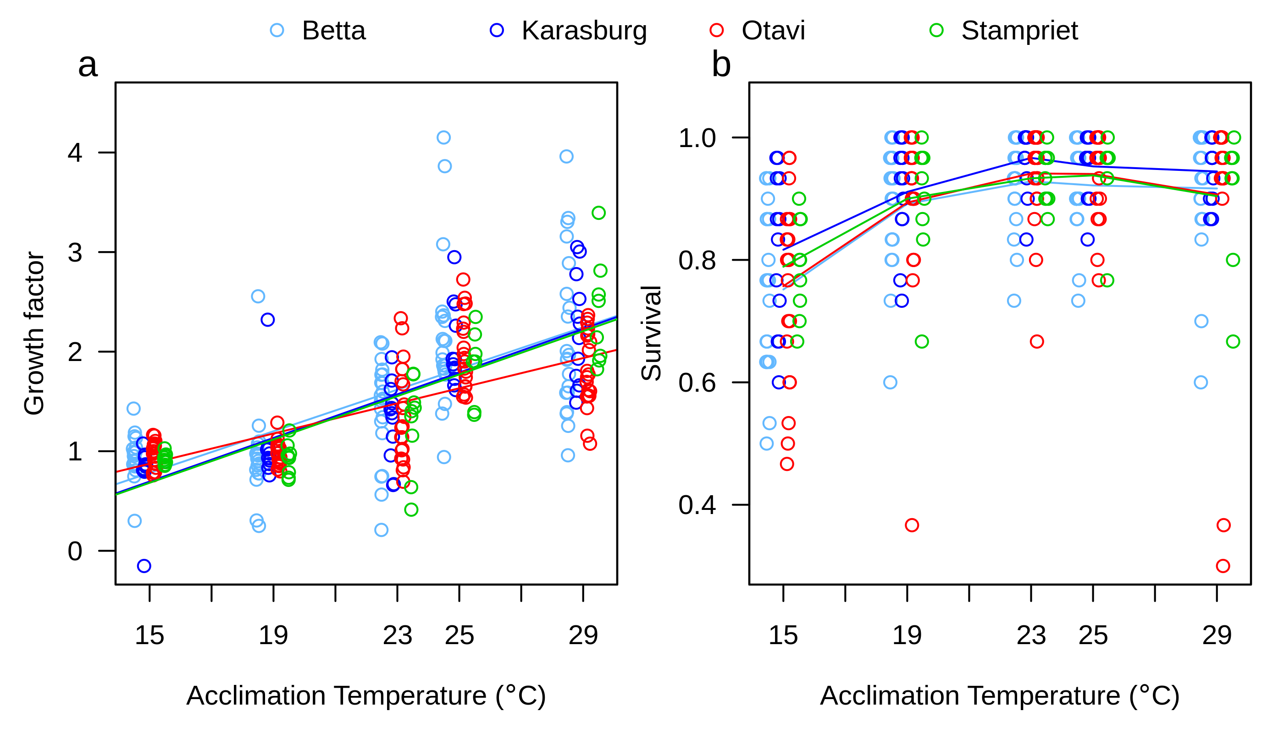

|  |  |
| --- | --- |
| growth groups | Survival: Treatment .group |
| 29 2.0895684 a | 1 15 a |
| 25 2.0595457 a | 2 19 b |
| 23 1.3633561 b | 5 29 bc |
| 19 0.9705685 c | 4 25 cd |
| 15 0.9221065 c | 3 23 d |
| NO EFFECT OF POP! (groups: a,a,a,a) | Karasburg is different. (a,a,a,b) |

**Figure S4:** Plots of CTmax as a function of days at 21, feeding status and mass. A linear trendline has been added to the plots for easier interpretation.

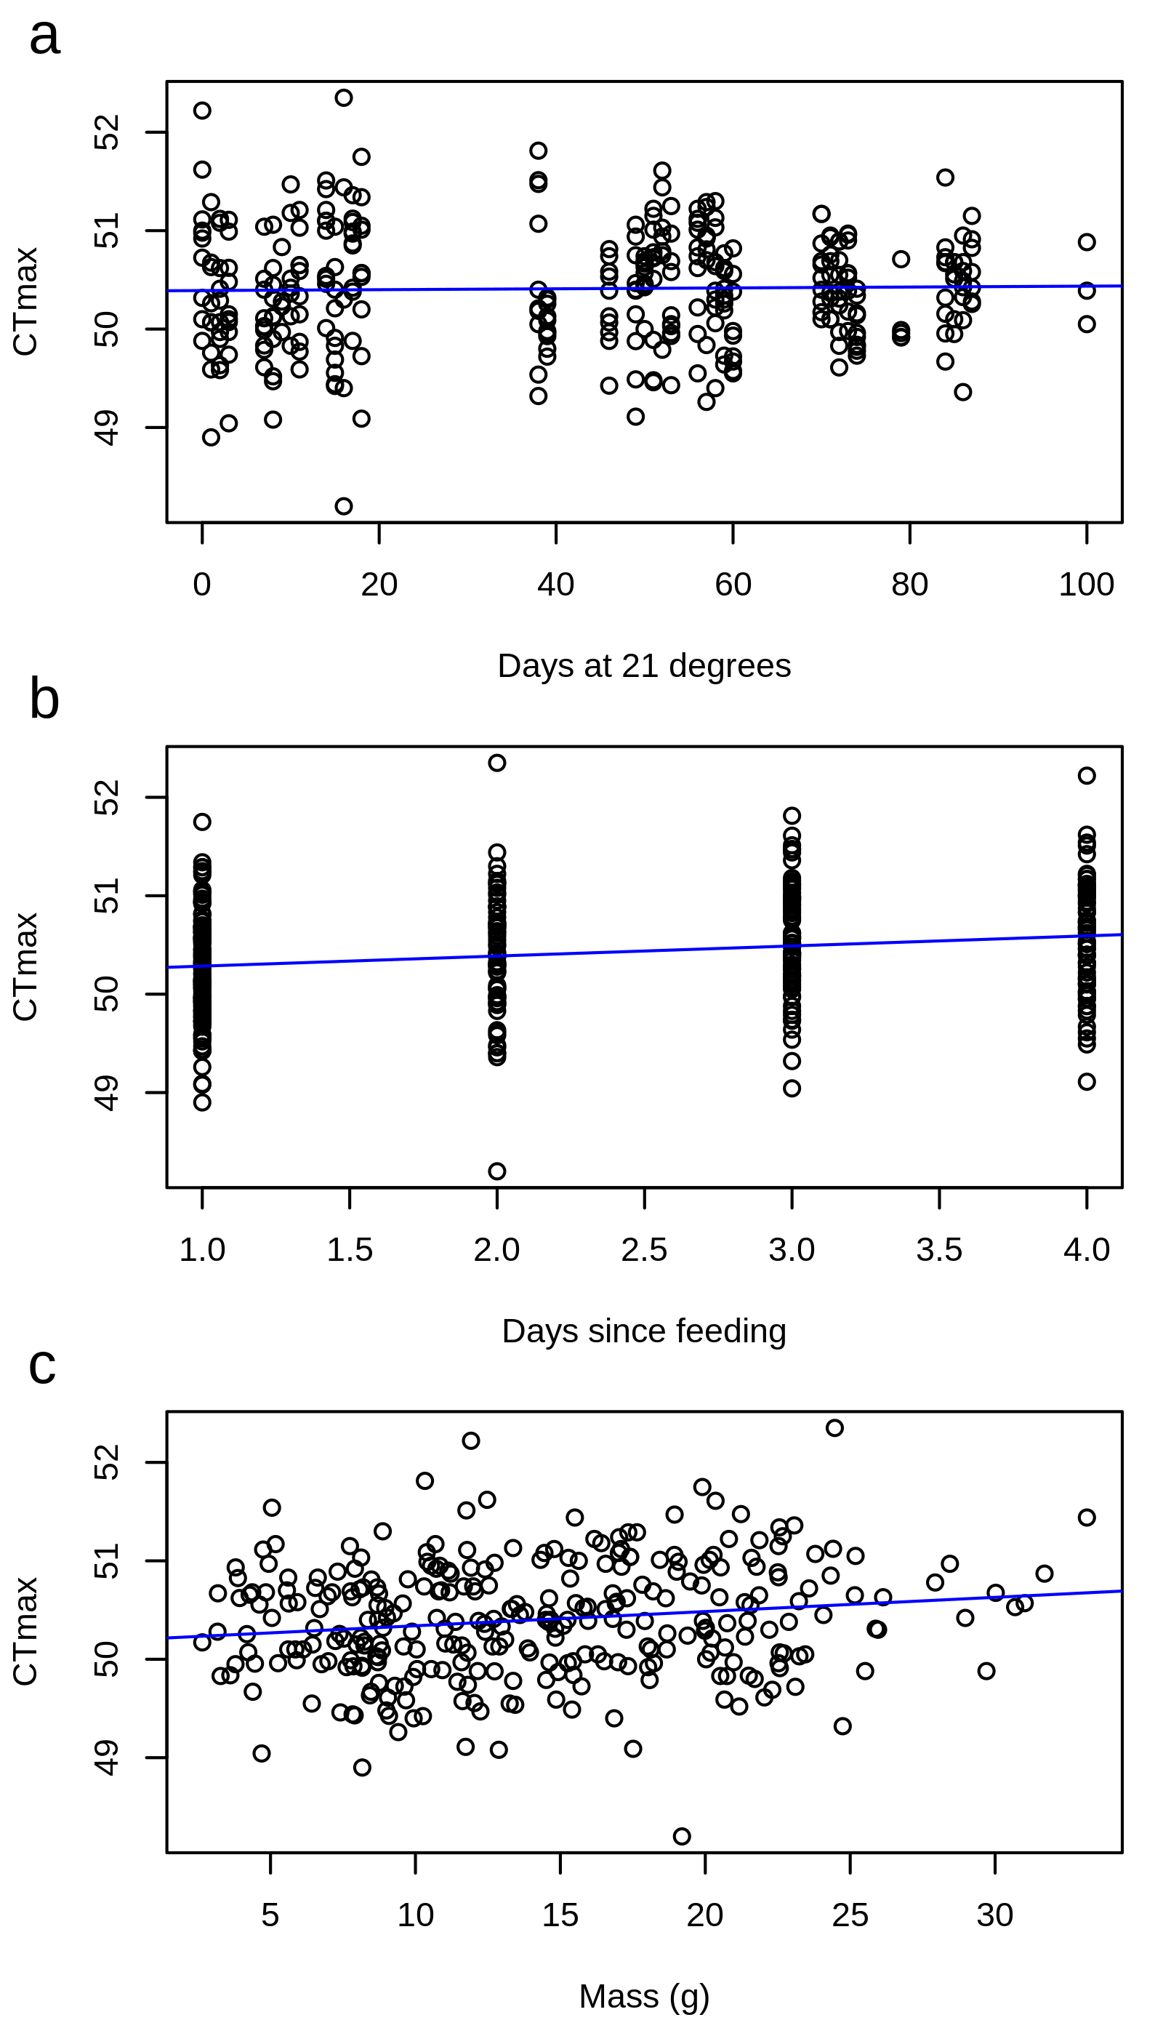

**Figure S5:**  Plot of the relationship between Mass and population (a and c) or temperature (b and d) for the spiders having undergone CTmax and CCR treatment. Betta and Karasburg are similar, while both Otavi and Stampriet are significantly different (a and c). Mass increases with acclimation temperature (b and d).

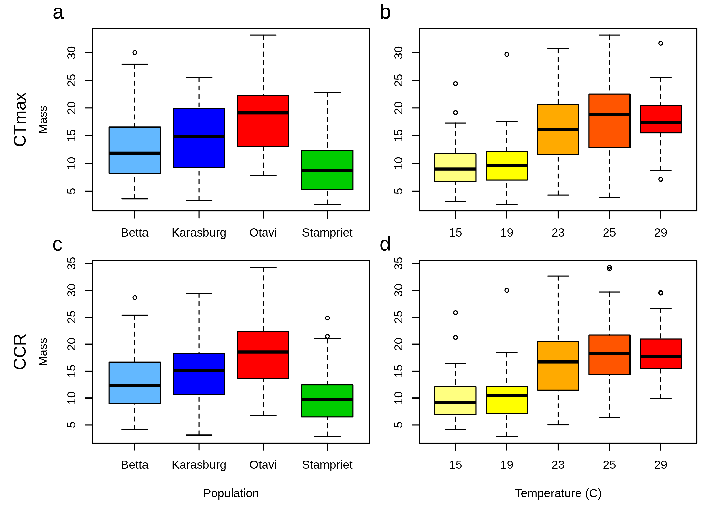

**Figure S6:** Plots of CCR as a function of days at 21, feeding status and mass. A linear trendline has been added to the plots for easier interpretation.

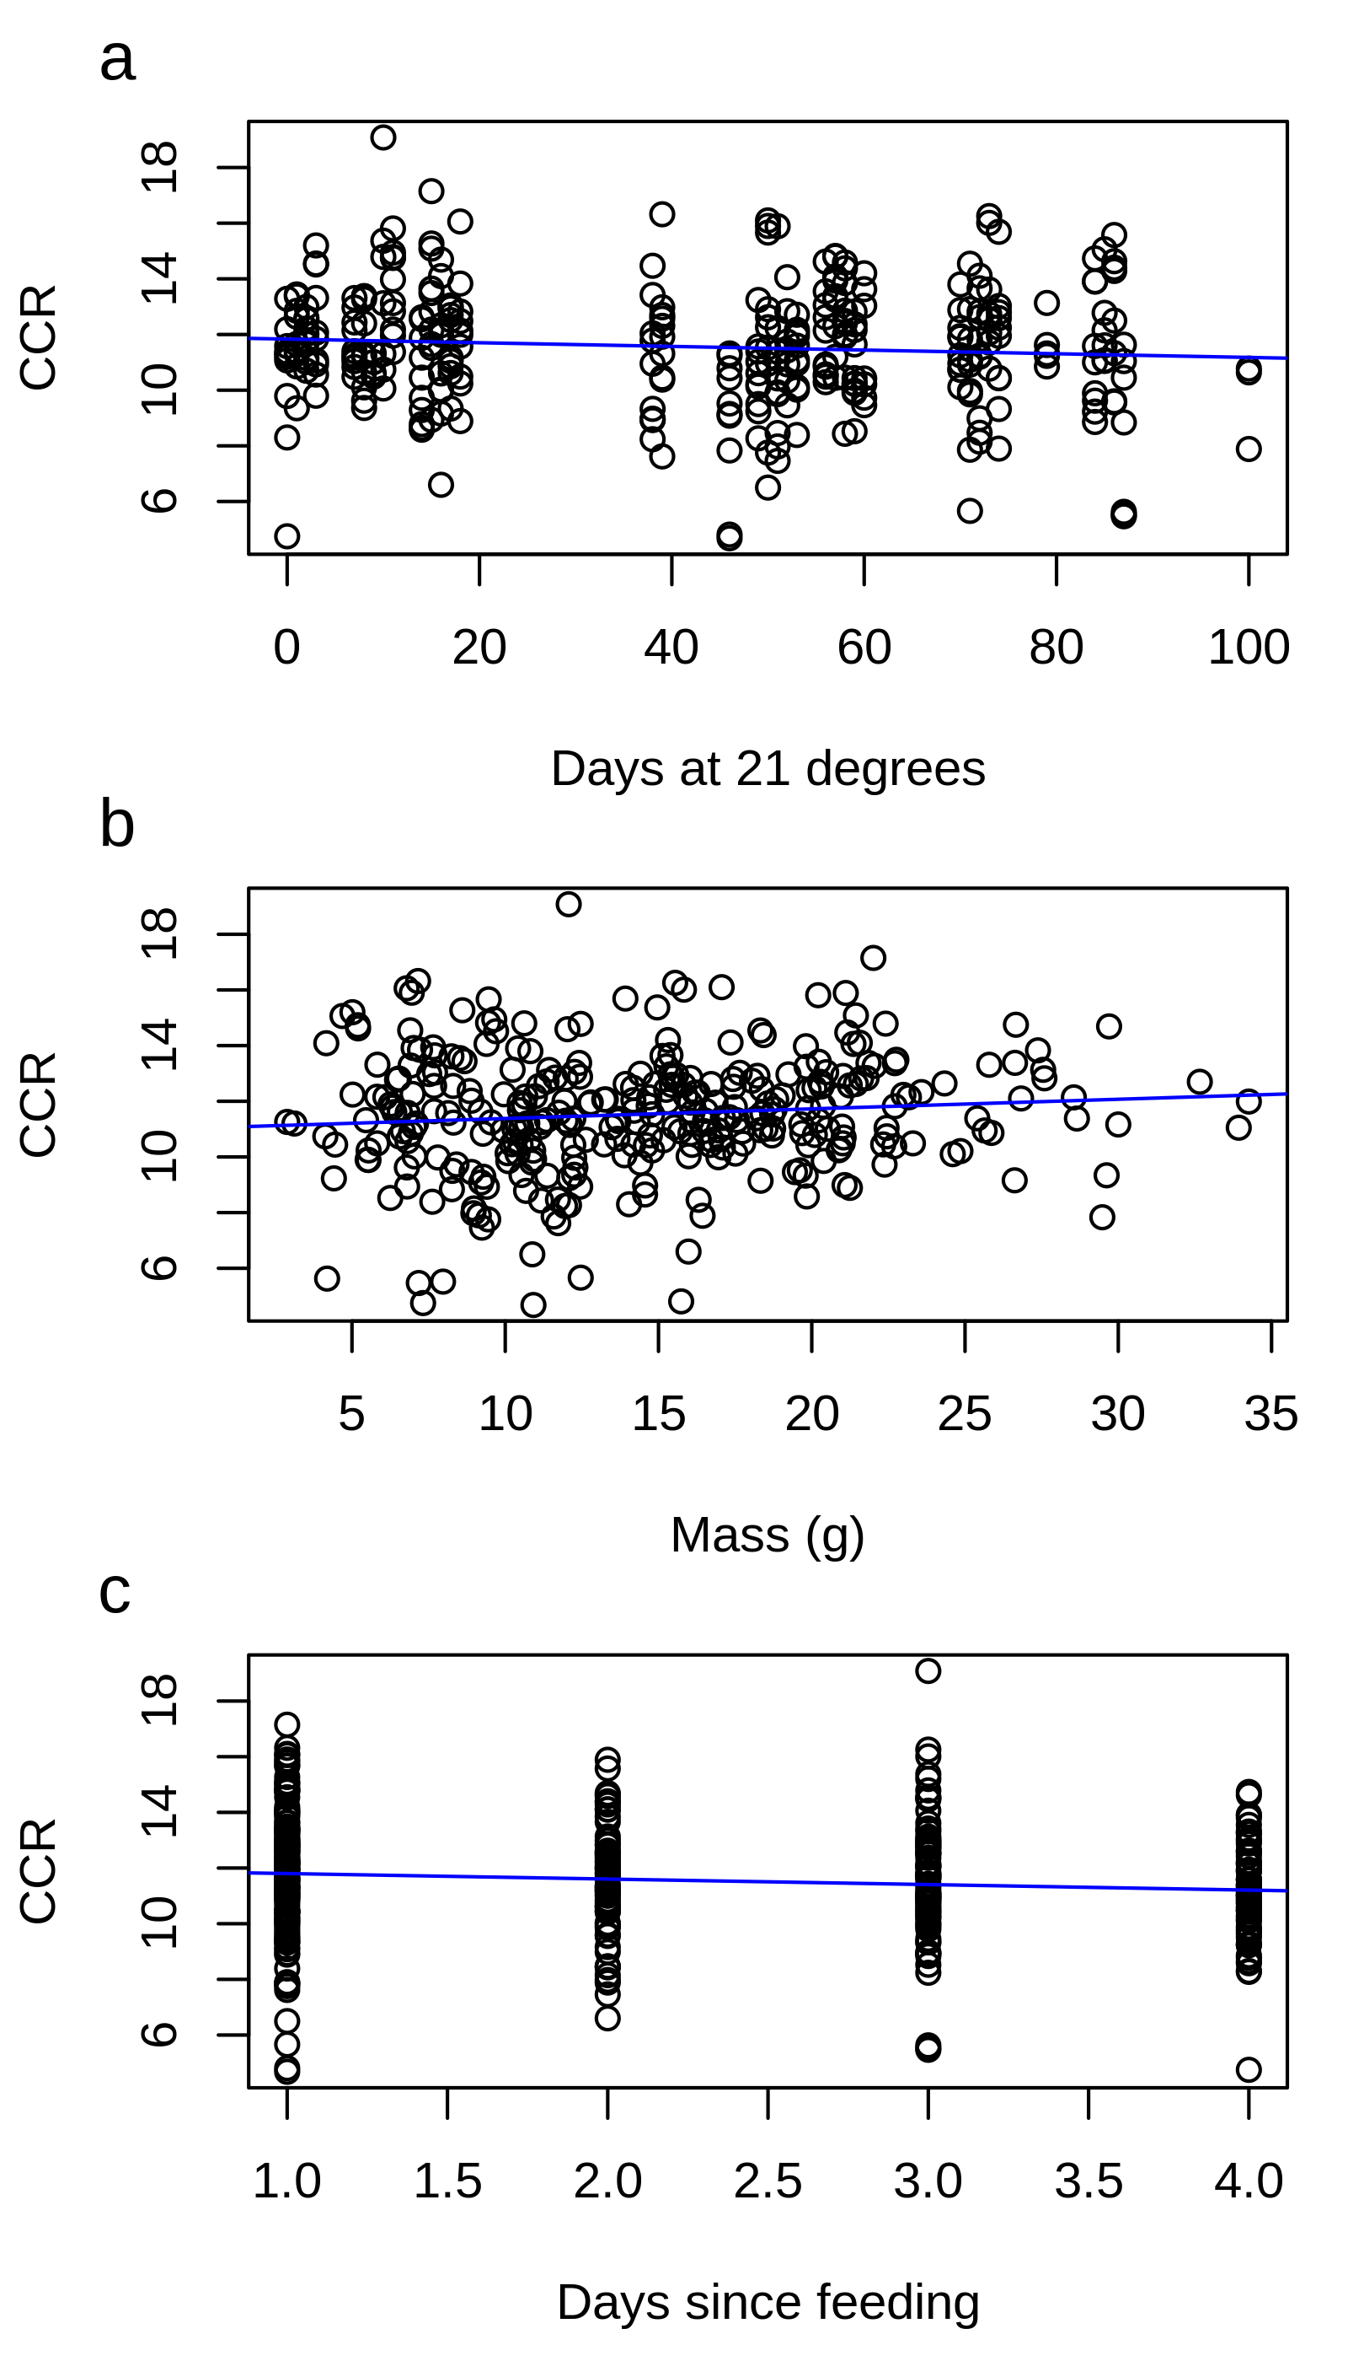

**Figure S7:** Histogram of correlation coefficients between weighted methylation level and vst transformed normatlized expression level (log2). All correlated genes showed a population response in both DNA methylation and gene expression.

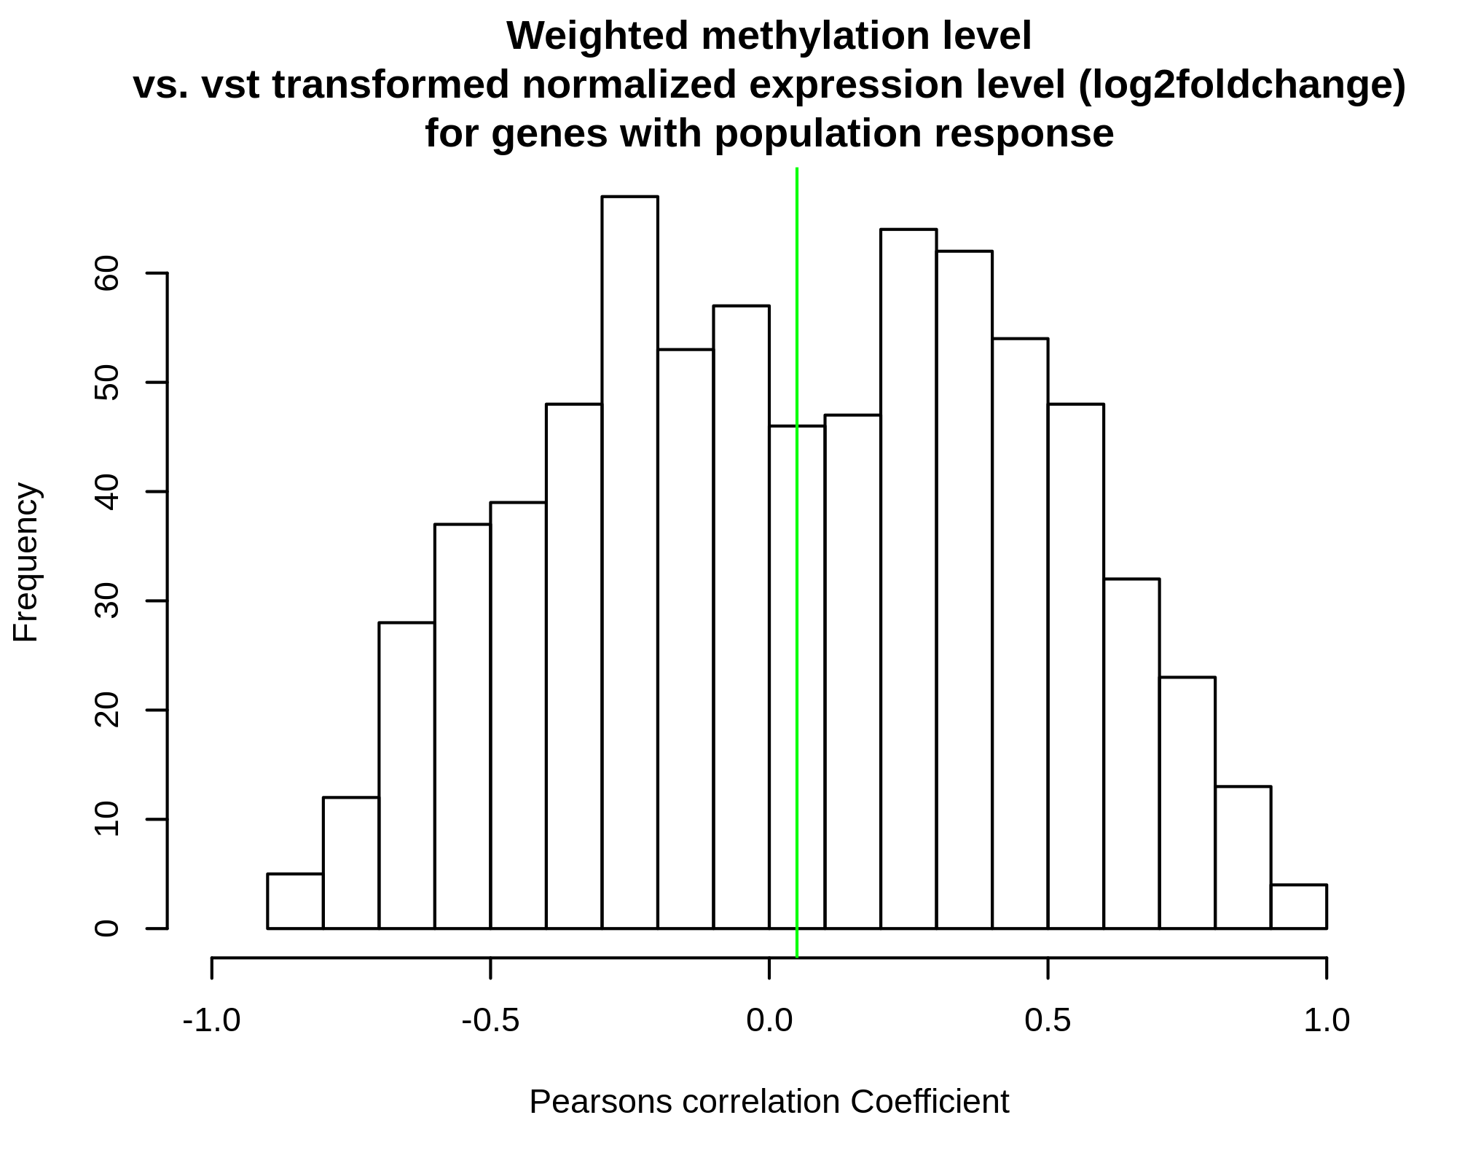

**Figure S8:** Histogram of correlation coefficients between weighted methylation level and Standard deviation of vst transformed normatlized expression level (log2). All correlated genes showed a population response in both DNA methylation and gene expression.

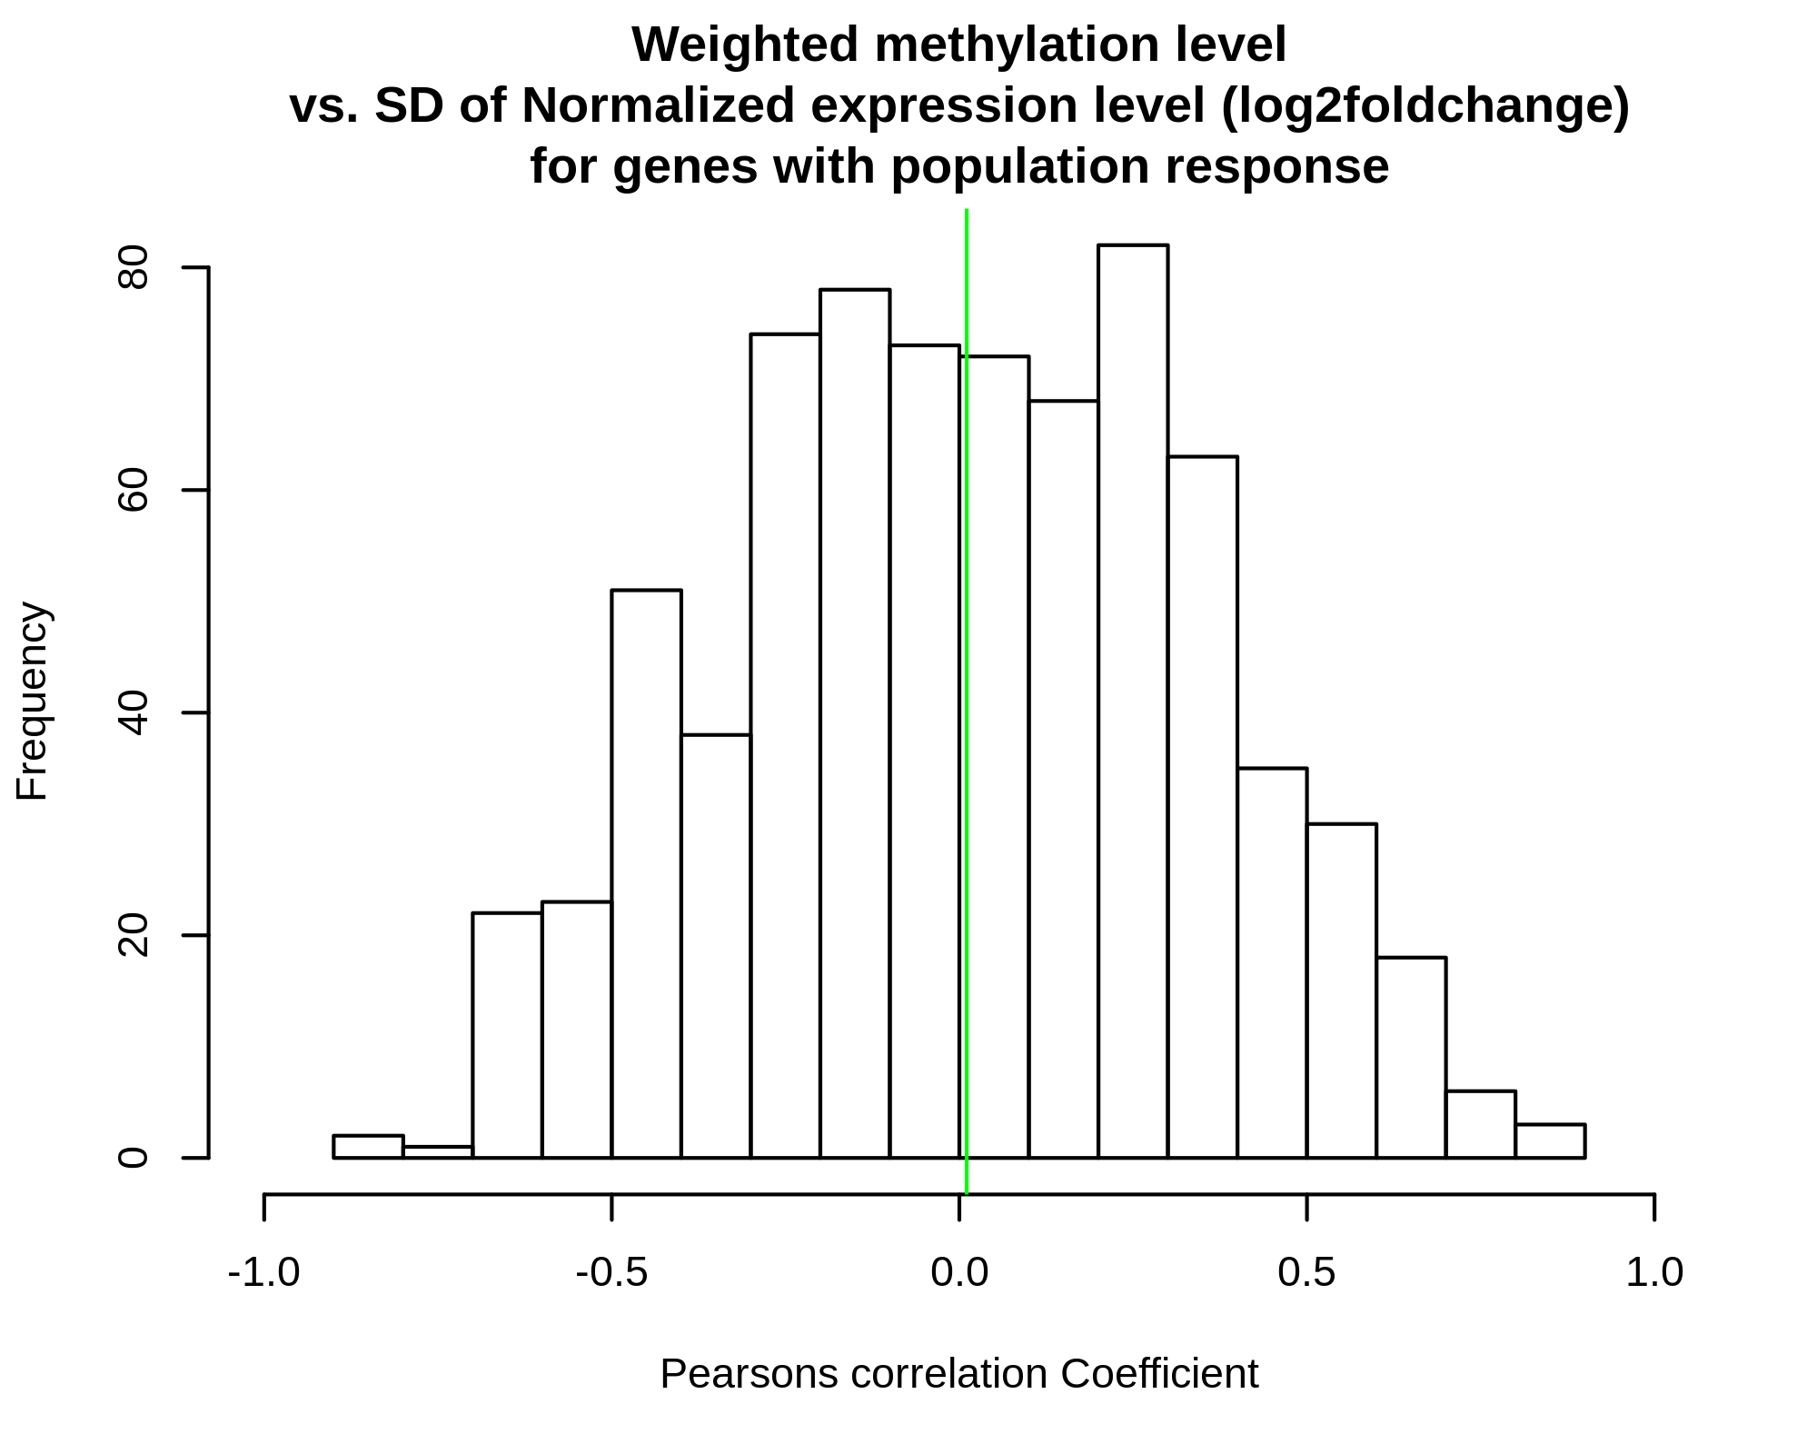

**Figure S9:** Ancestral loss or gain of plasticity for temperature tolerances.

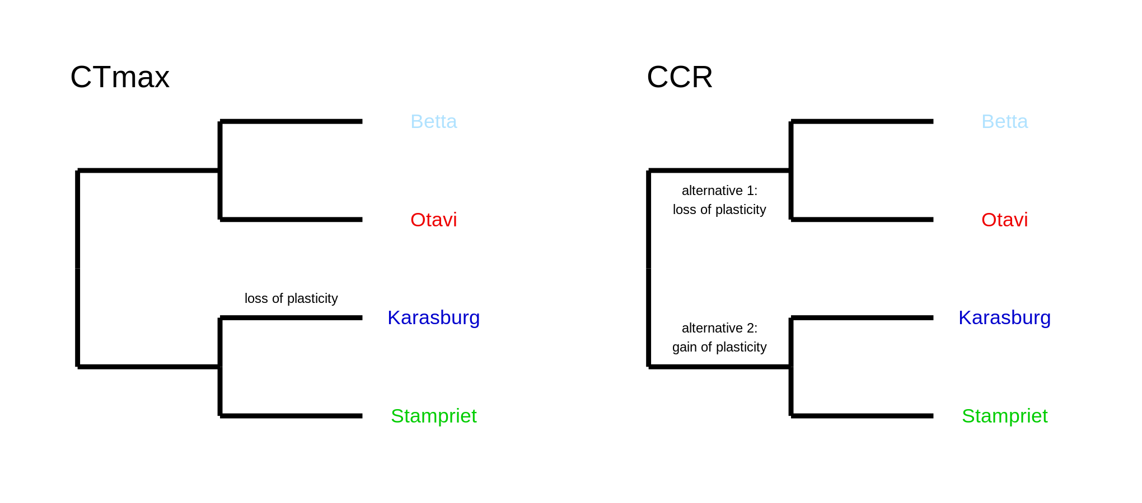

**Figure S10**: Methylation PCA plots, including Scree- and biplot.

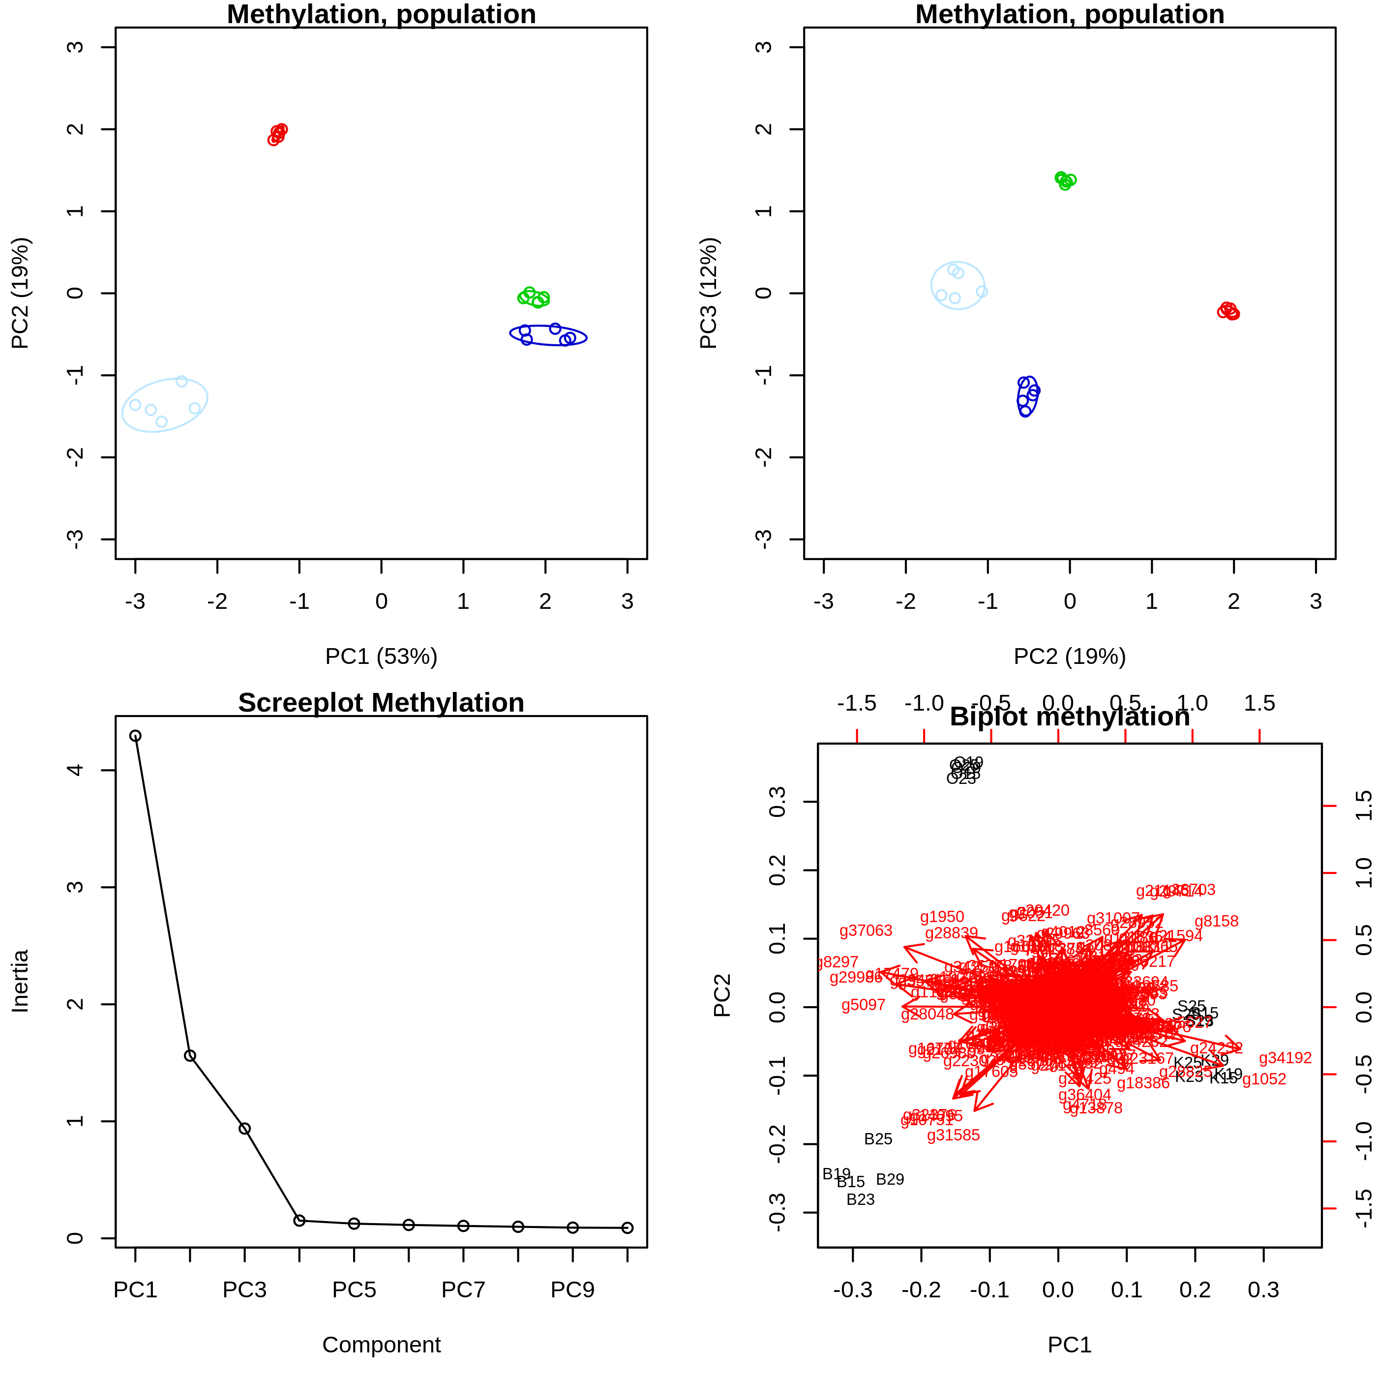

**Figure S11:** Principal component analysis on differentially expressed genes according to population of origin. There is a tendency for Otavi (red) and Betta (light blue) to separate from Karasburg (blue) and Stampriet (green)

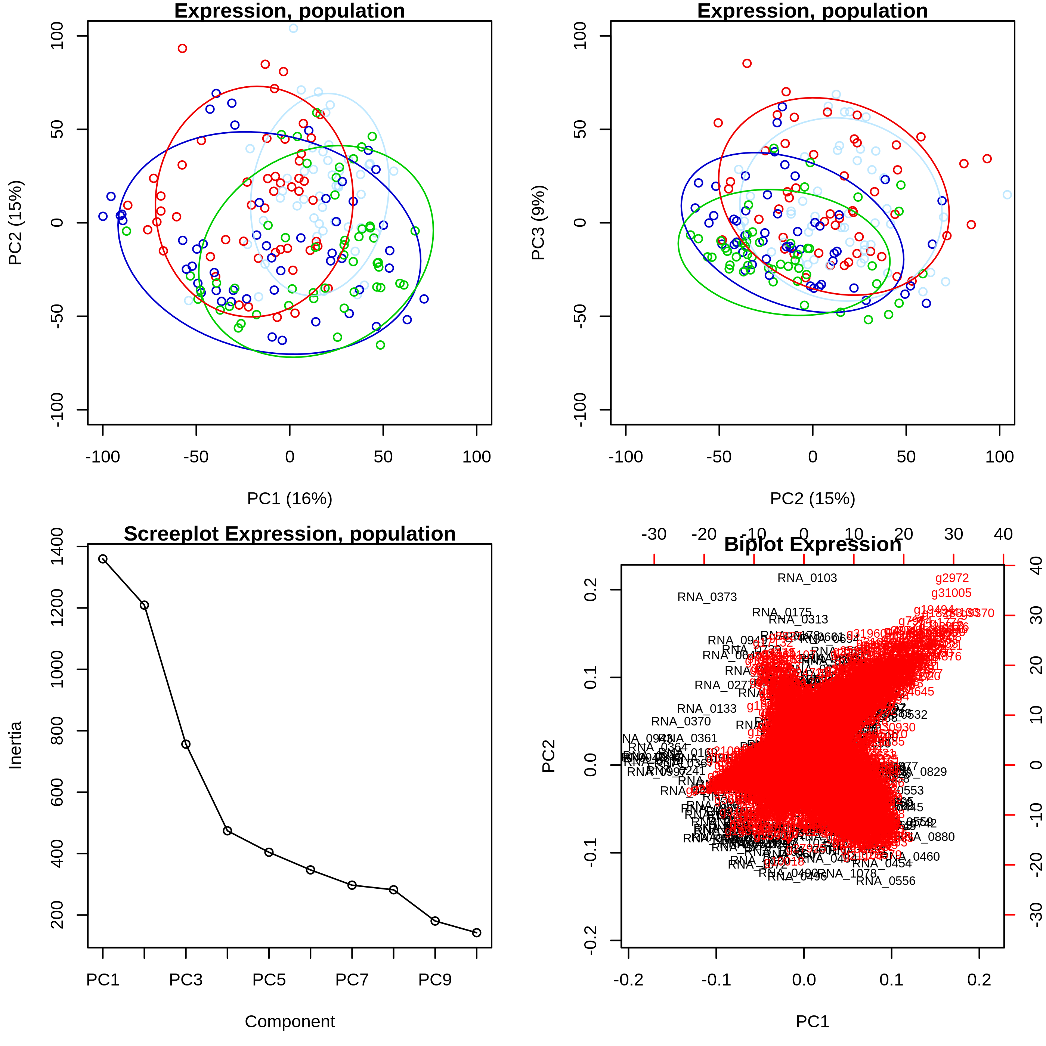

**Figure S12:** PCA analysis on differentially expressed genes with interaction, ordination plots, scree- and biplot.

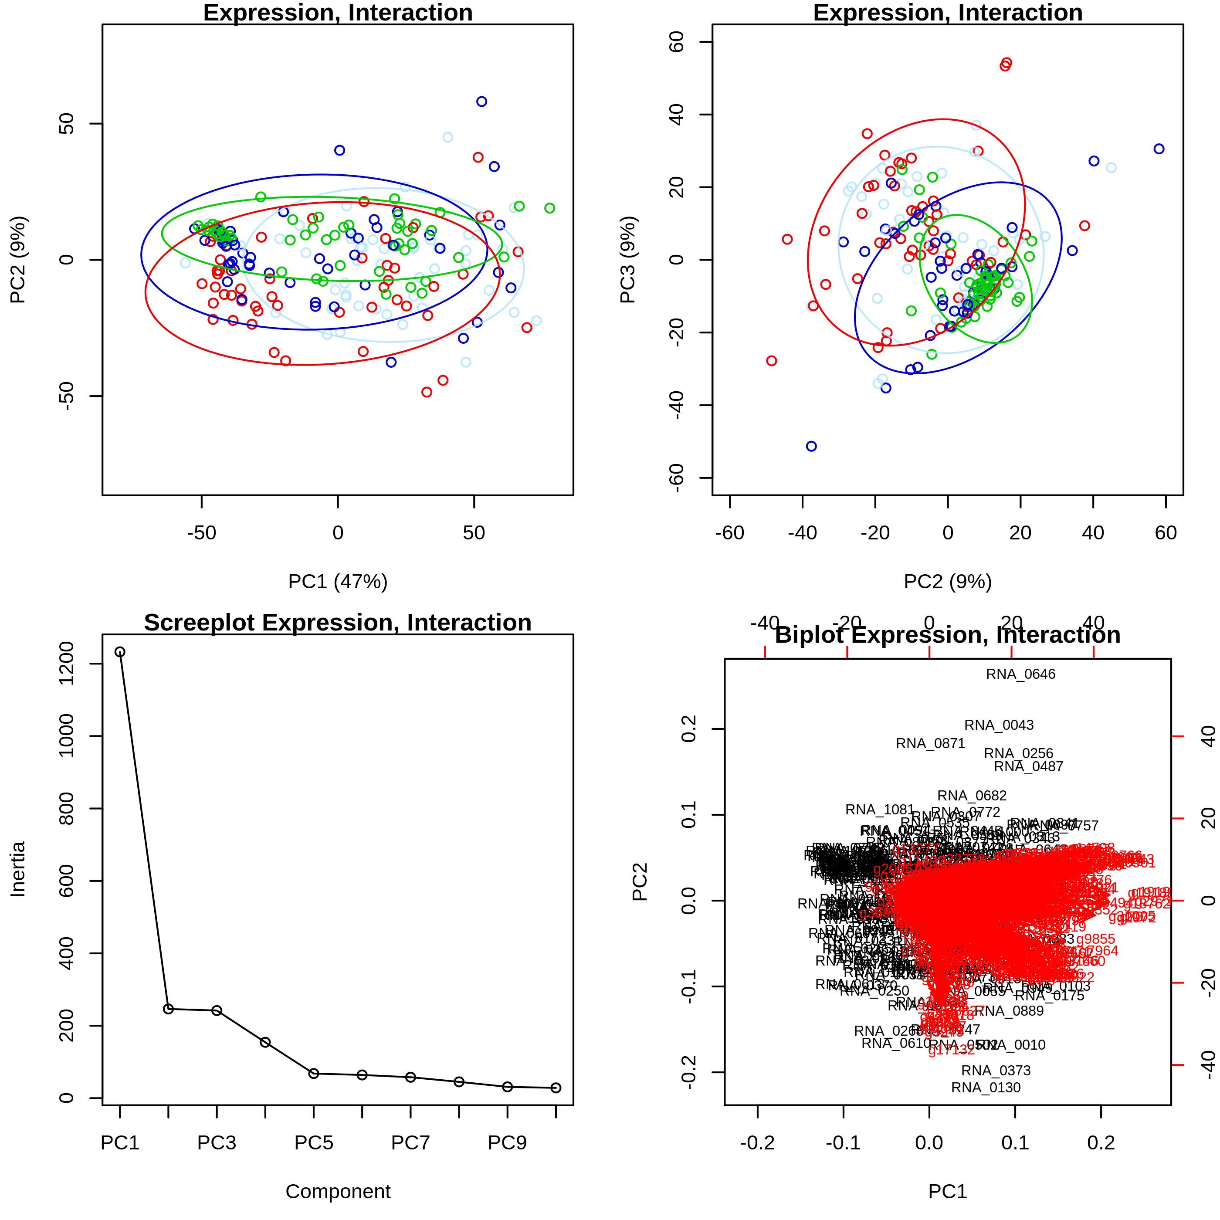

**Figure S13**: Stability of expression, individual genes weighted methylation level vs. standard deviation in expression. Only genes showing effects of population in methylation level was included. Each gene has 20 points on the dot plot, one from each acclimation/treatment group. Colors indicate population. Low methylation level is significantly different to medium and high (significance group a,b,b).

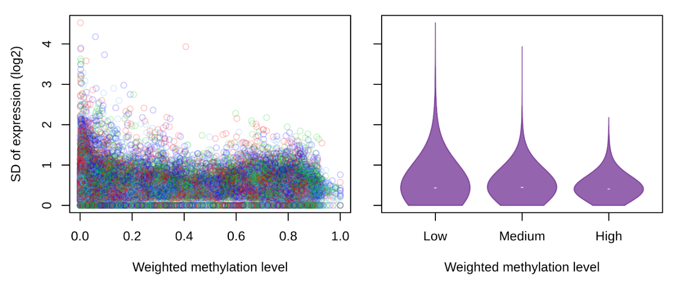

**Figure S14**: PCA plot of microbiome ASVs with population effects.

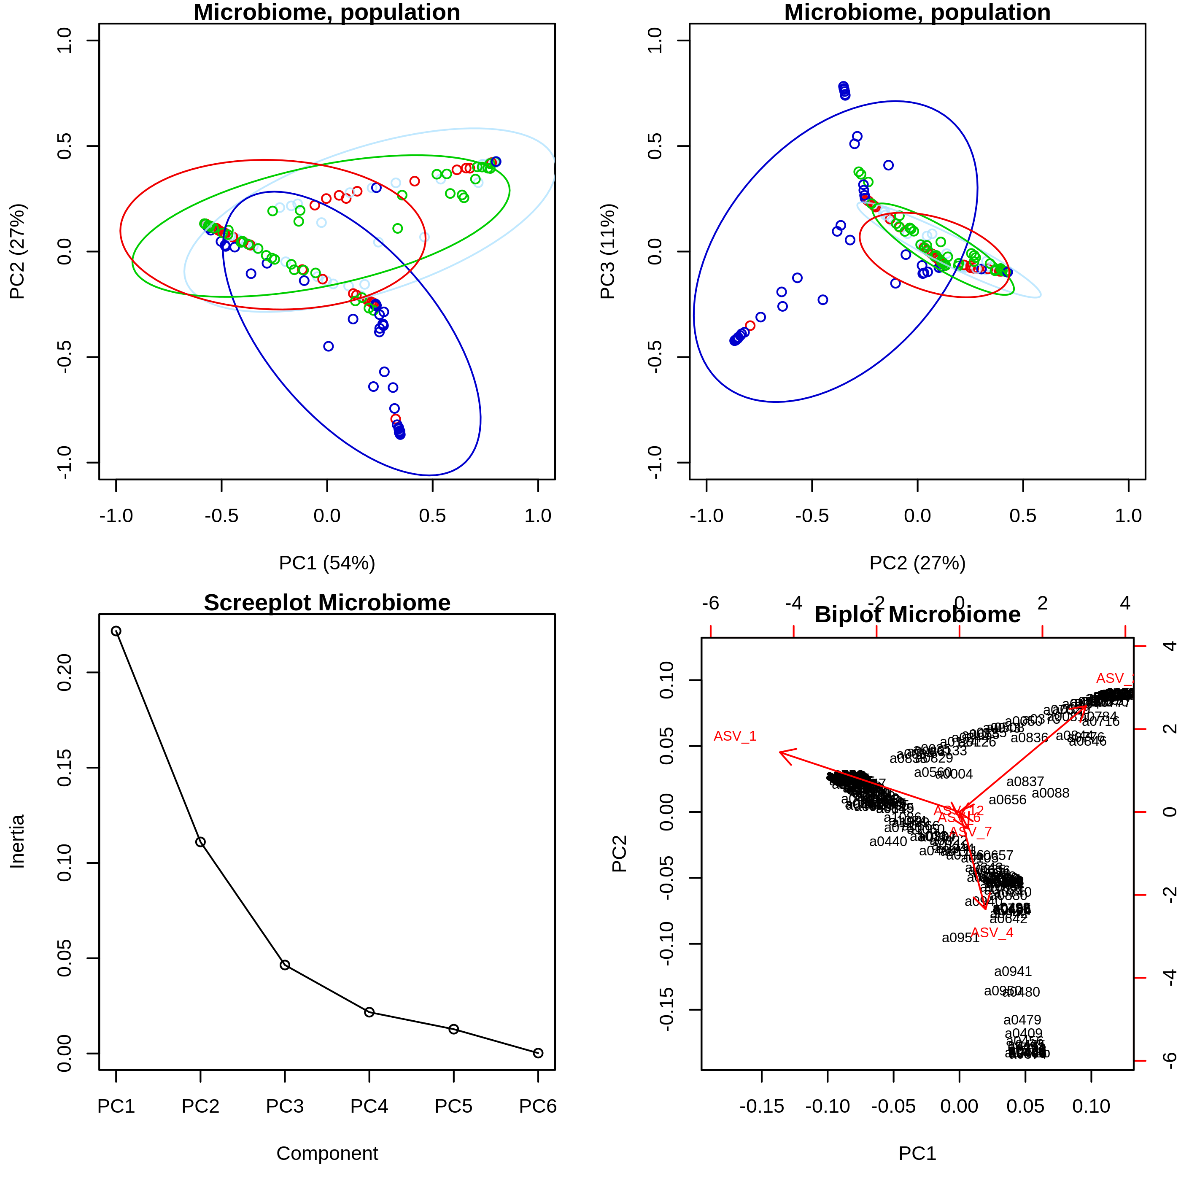

**Figure S15**: Acclimation plots of ASVs with population effect.

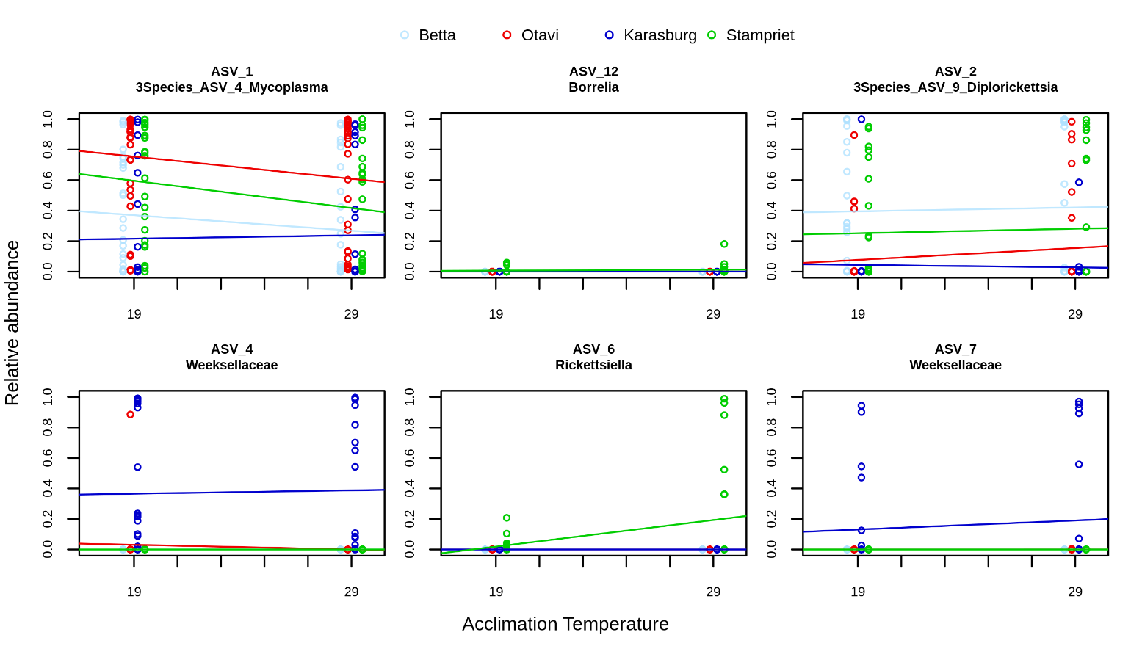

**Figure S16**: PCA of LCMS CTmax

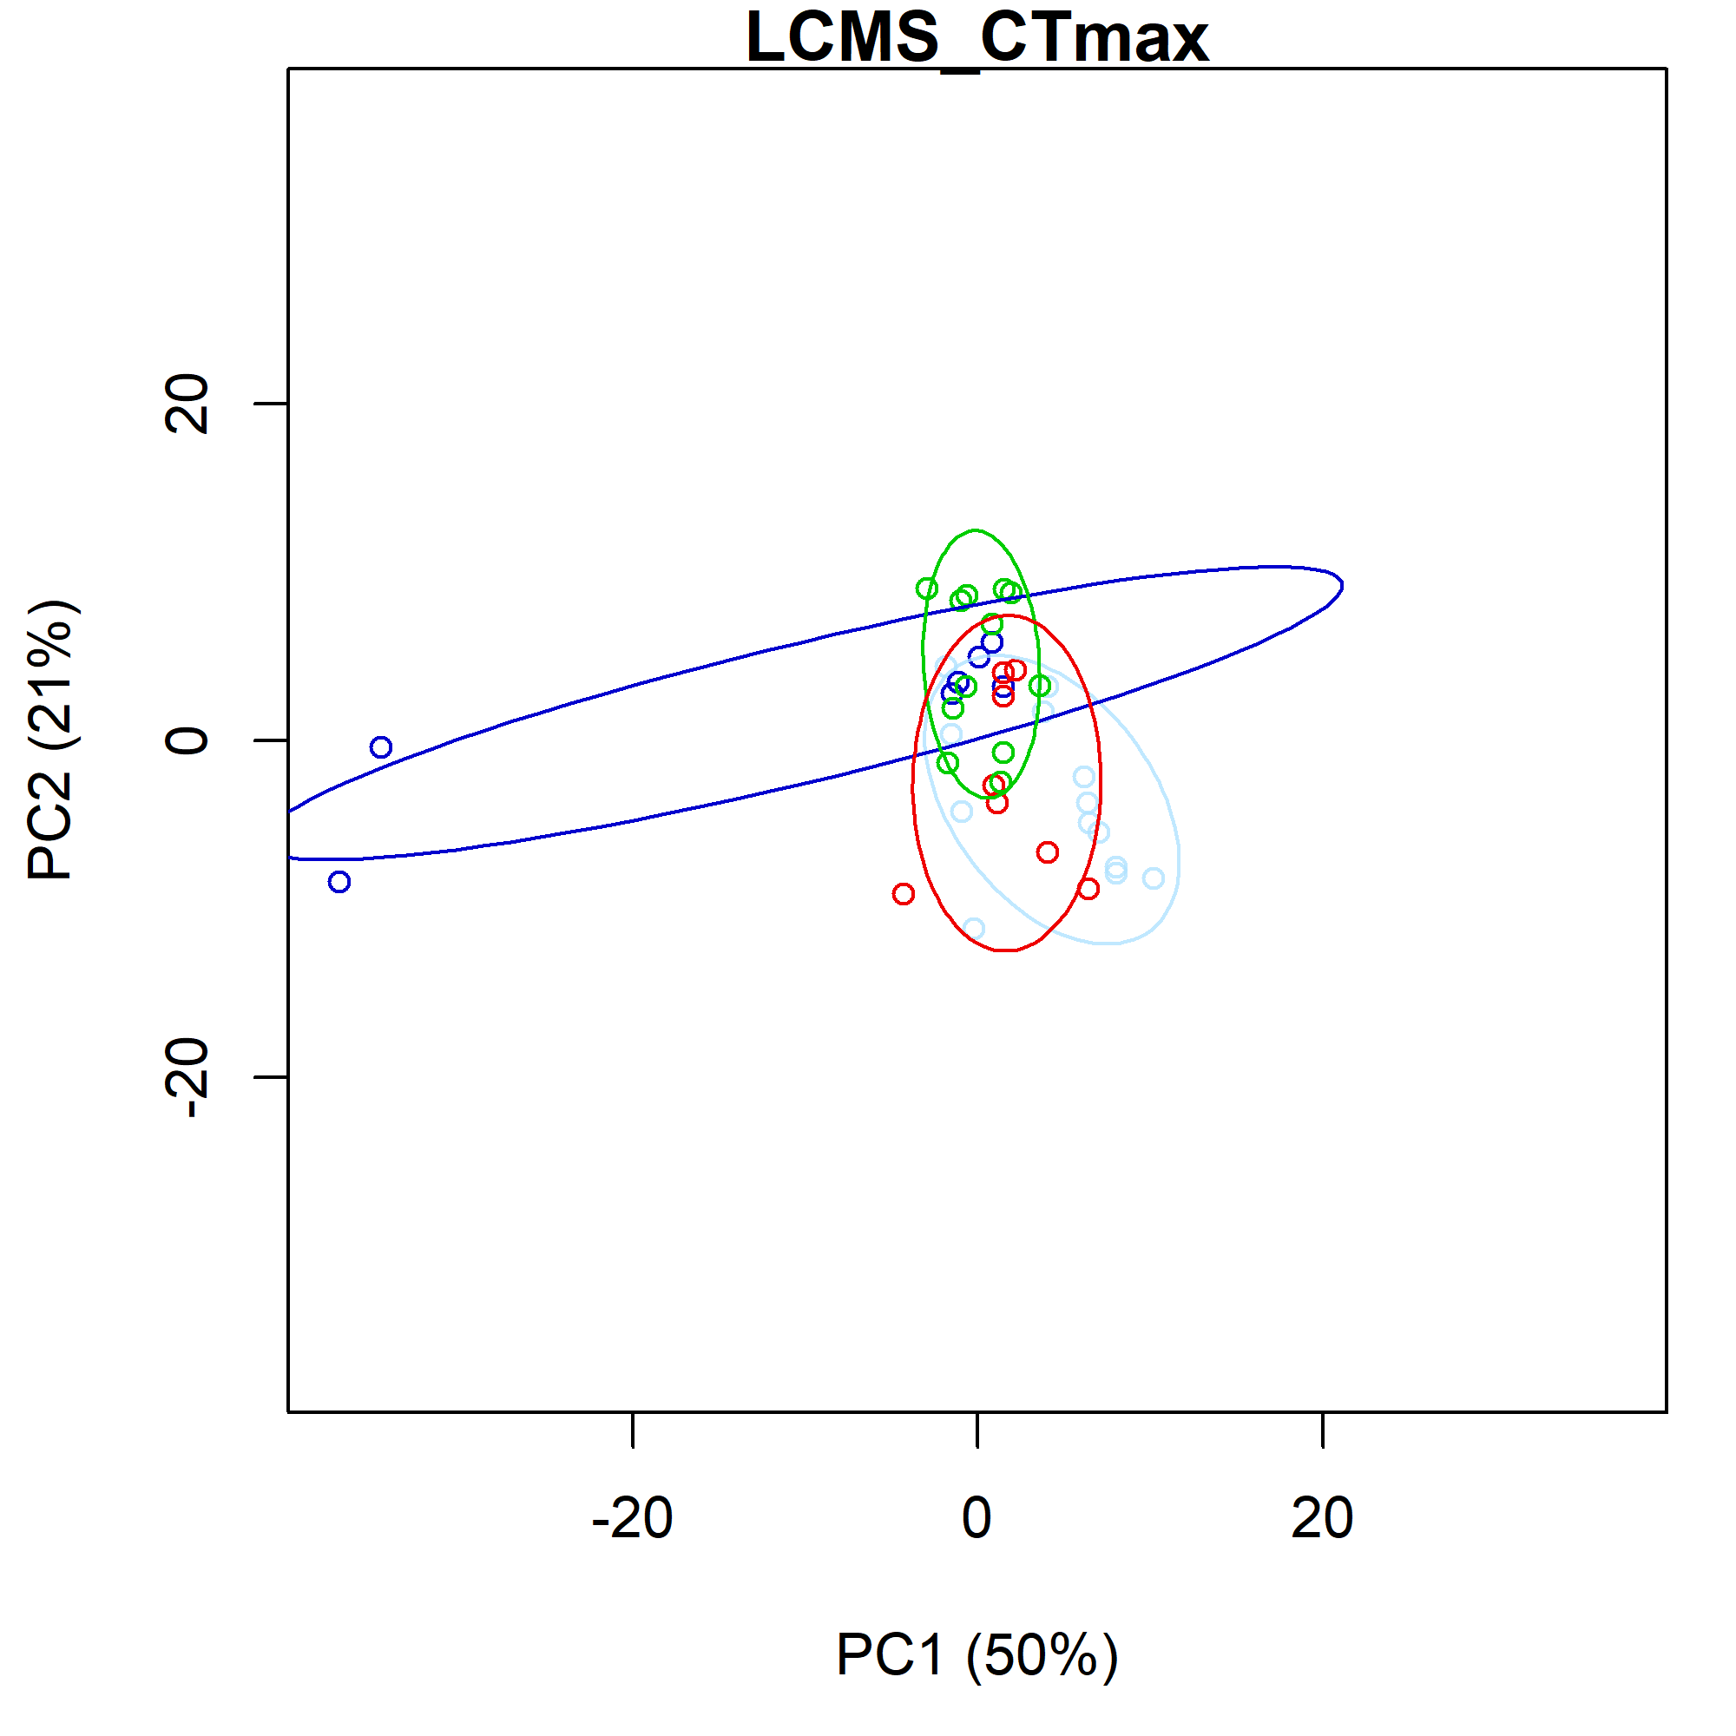 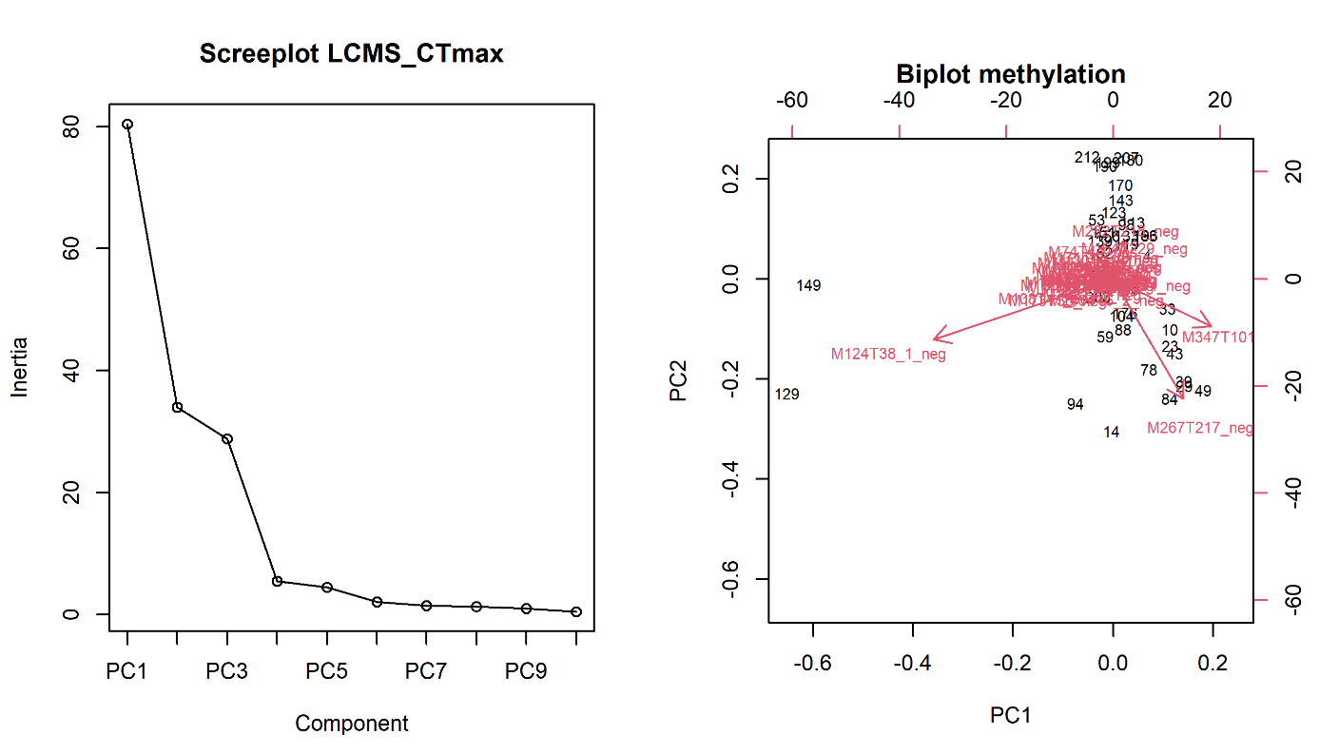

**Figure S17**: PCA of LCMS CCR

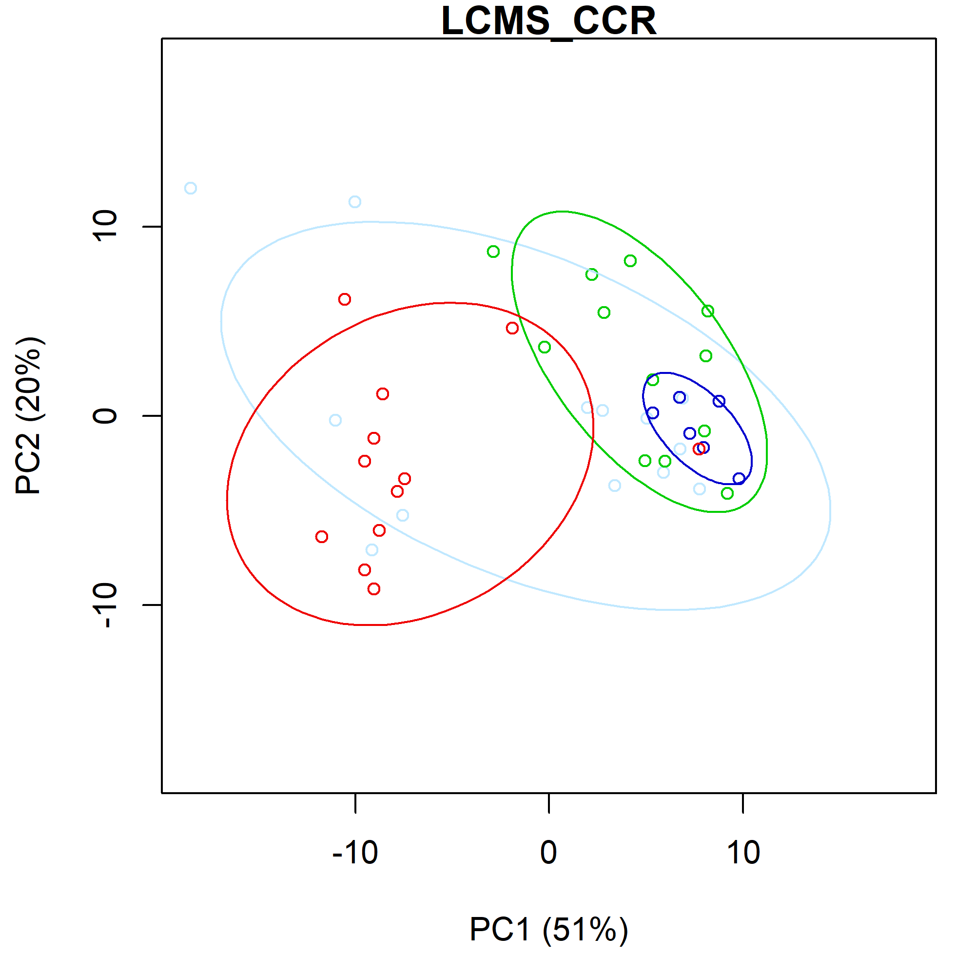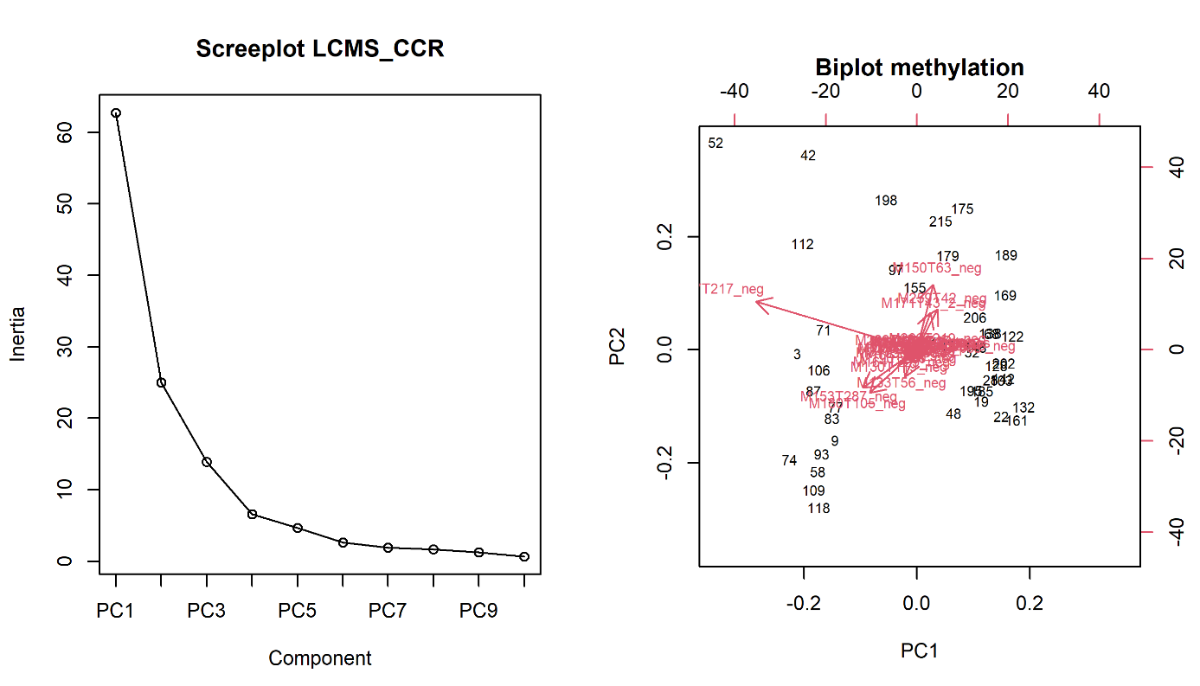

**Table SXGROW**:

Supplementary table XGROW

|  |  |  |  |  |  |
| --- | --- | --- | --- | --- | --- |
|  | **growth** | | | | |
| *Predictors* | *Estimates* | *std. Error* | *CI* | *Statistic* | *p* |
| (Intercept) | -0.78 *** | 0.23 | -1.24 – -0.33 | -3.40 | **0.001** |
| Population [Karasburg] | -0.16 | 0.38 | -0.90 – 0.58 | -0.43 | 0.667 |
| Population [Otavi] | 0.52 | 0.32 | -0.11 – 1.16 | 1.62 | 0.107 |
| Population [Stampriet] | -0.16 | 0.42 | -0.99 – 0.66 | -0.39 | 0.695 |
| Treatment | 0.10 *** | 0.01 | 0.08 – 0.12 | 10.29 | **<0.001** |
| Population [Karasburg] * Treatment | 0.01 | 0.02 | -0.03 – 0.04 | 0.30 | 0.762 |
| Population [Otavi] * Treatment | -0.03 * | 0.01 | -0.06 – -0.00 | -2.01 | **0.045** |
| Population [Stampriet] * Treatment | 0.00 | 0.02 | -0.03 – 0.04 | 0.23 | 0.817 |
| Observations | 304 | | | | |
| R2 / R2 adjusted | 0.490 / 0.478 | | | | |
| AIC | 439.668 | | | | |
| F-statistic | 40.66 on 7 and 296 DF | | | | |
| p-value | < 2.2e-16 | | | | |
| *\* p<0.05   ** p<0.01   *** p<0.001* | | | | | |

**Table SXSURV**:

Supplementary table XSURV

|  |  |  |  |  |  |
| --- | --- | --- | --- | --- | --- |
|  | **as.matrix(surv_deaths_dat[, 1:2])** | | | | |
| *Predictors* | *Odds Ratios* | *std. Error* | *CI* | *Statistic* | *p* |
| (Intercept) | 0.74 | 0.12 | 0.54 – 1.01 | -1.91 | 0.056 |
| Population [Karasburg] | 1.52 *** | 0.16 | 1.24 – 1.87 | 4.02 | **<0.001** |
| Population [Otavi] | 1.06 | 0.09 | 0.90 – 1.25 | 0.73 | 0.466 |
| Population [Stampriet] | 1.13 | 0.12 | 0.91 – 1.39 | 1.10 | 0.274 |
| Treatment | 1.12 *** | 0.01 | 1.10 – 1.13 | 14.82 | **<0.001** |
| Observations | 304 | | | | |
| R2 Tjur | 0.010 | | | | |
| R2 McFadden | 0.126 | | | | |
| AIC | 1754.826 | | | | |
| p-value (to null model) | < 2.2e-16 | | | | |
| *\* p<0.05   ** p<0.01   *** p<0.001* | | | | | |

**Table SXCTMAX**:

Supplementary table XCTMAX

|  |  |  |  |  |  |
| --- | --- | --- | --- | --- | --- |
|  | **ToD_mean** | | | | |
| *Predictors* | *Estimates* | *std. Error* | *CI* | *Statistic* | *p* |
| (Intercept) | 48.10 *** | 0.23 | 47.66 – 48.54 | 213.06 | **<0.001** |
| Population [Karasburg] | 1.53 *** | 0.35 | 0.84 – 2.22 | 4.38 | **<0.001** |
| Population [Otavi] | 0.47 | 0.32 | -0.15 – 1.09 | 1.48 | 0.139 |
| Population [Stampriet] | 1.21 *** | 0.35 | 0.53 – 1.90 | 3.48 | **0.001** |
| Treatment | 0.10 *** | 0.01 | 0.08 – 0.12 | 10.06 | **<0.001** |
| Mass mean | -0.01 * | 0.01 | -0.02 – -0.00 | -1.97 | **0.050** |
| Fed mean | 0.05 * | 0.02 | 0.00 – 0.10 | 2.09 | **0.037** |
| D 21 mean | 0.00 * | 0.00 | 0.00 – 0.01 | 2.24 | **0.026** |
| Population [Karasburg] * Treatment | -0.08 *** | 0.02 | -0.11 – -0.05 | -5.35 | **<0.001** |
| Population [Otavi] * Treatment | -0.02 | 0.01 | -0.05 – 0.01 | -1.28 | 0.202 |
| Population [Stampriet] * Treatment | -0.06 *** | 0.02 | -0.09 – -0.03 | -4.07 | **<0.001** |
| Observations | 309 | | | | |
| R2 / R2 adjusted | 0.409 / 0.389 | | | | |
| AIC | 407.455 | | | | |
| F-statistic | 20.61 on 10 and 298 DF | | | | |
| p-value | < 2.2e-16 | | | | |
| *\* p<0.05   ** p<0.01   *** p<0.001* | | | | | |

**Table SXCCR**:

Supplementary table XCCR

|  |  |  |  |  |  |
| --- | --- | --- | --- | --- | --- |
|  | **CCR_mean** | | | | |
| *Predictors* | *Estimates* | *std. Error* | *CI* | *Statistic* | *p* |
| (Intercept) | 12.31 *** | 1.00 | 10.33 – 14.28 | 12.26 | **<0.001** |
| Population [Karasburg] | -4.68 ** | 1.56 | -7.75 – -1.60 | -2.99 | **0.003** |
| Population [Otavi] | 0.47 | 1.38 | -2.23 – 3.18 | 0.34 | 0.731 |
| Population [Stampriet] | -2.96 | 1.54 | -6.00 – 0.08 | -1.92 | 0.056 |
| Treatment | 0.03 | 0.05 | -0.07 – 0.12 | 0.59 | 0.557 |
| Mass mean | -0.04 | 0.03 | -0.10 – 0.01 | -1.50 | 0.134 |
| Fed | -0.31 ** | 0.11 | -0.52 – -0.10 | -2.93 | **0.004** |
| Population [Karasburg] * Treatment | 0.17 * | 0.07 | 0.04 – 0.31 | 2.50 | **0.013** |
| Population [Otavi] * Treatment | 0.00 | 0.06 | -0.11 – 0.12 | 0.08 | 0.935 |
| Population [Stampriet] * Treatment | 0.11 | 0.07 | -0.02 – 0.24 | 1.62 | 0.105 |
| Observations | 330 | | | | |
| R2 / R2 adjusted | 0.098 / 0.073 | | | | |
| AIC | 1427.653 | | | | |
| F-statistic | 3.862 on 9 and 320 DF | | | | |
| p-value | 0.0001159 | | | | |
| *\* p<0.05   ** p<0.01   *** p<0.001* | | | | | |

Supplementary comment 1:

## Potential confounding factors

The spiders from all four populations were sampled over a relatively short period resulting in non-synchronized phenology due to population differences. Despite the effort to test the spiders in size dependent order, they still had different sizes when testing their thermal limits as estimated by mass (anova, p-value < 2e-16 in all acclimation regimes in both CTmax and CCR). The spiders from Otawi were heaviest, followed by spiders from Karasburg, Betta, and Stampriet (Figure S5). In order to test if the size difference among populations represents a potential confounding factor regarding their thermal tolerances, we correlated individual CTmax and CCR with masses for each population separately. In most tests there were non-significant correlations, and no common trend was observed. On the contrary, sometimes there are a negative trend and sometimes a positive. Additionally, there is no correlation between the population’s average CTmax and CCR, and their average masses. We consequently did not keep mass in the subsequent analyses. The same arguments are used to not include the time between the spiders were fed and tested, and the time in common lab before acclimation in subsequent analyses (Figure S3 and 5). In summary, the size of the spiders, their hunger state, and time under common lab conditions before thermal acclimation, do not seem to influence their thermal tolerances.